


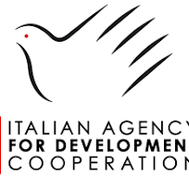
Project Launching Inception Report: Site-Level Community Engagement
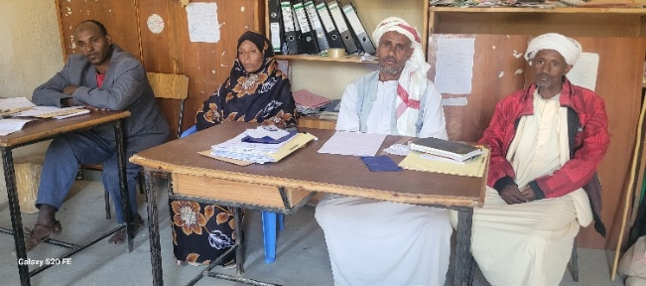
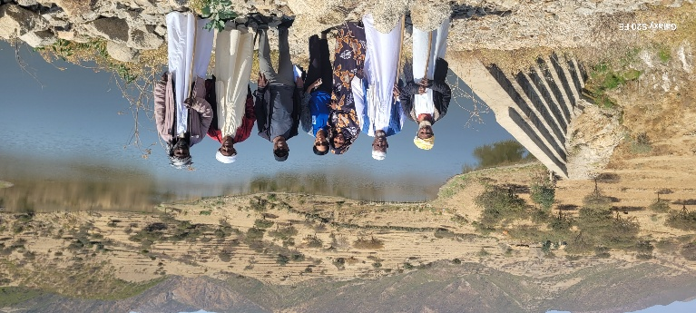
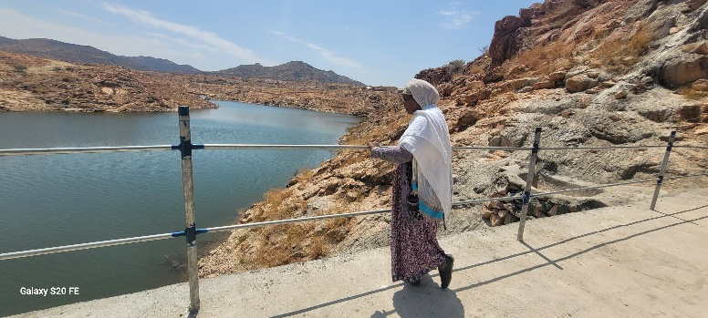
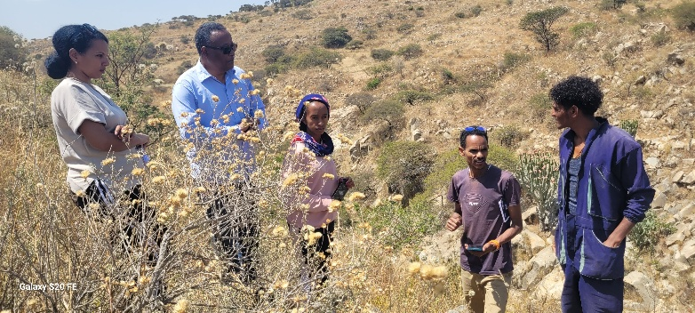
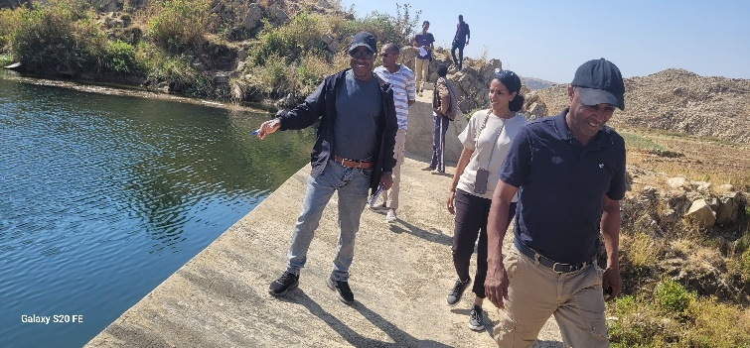
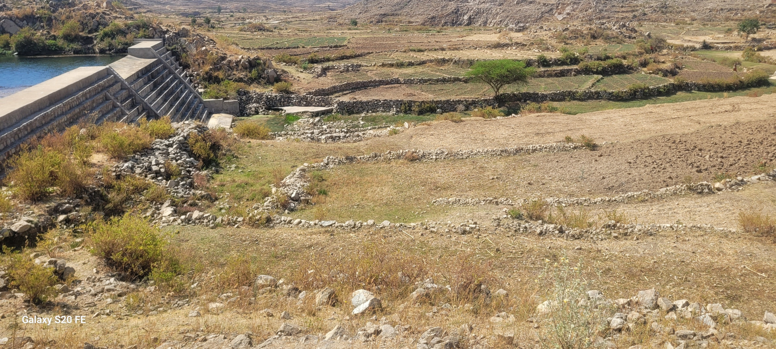
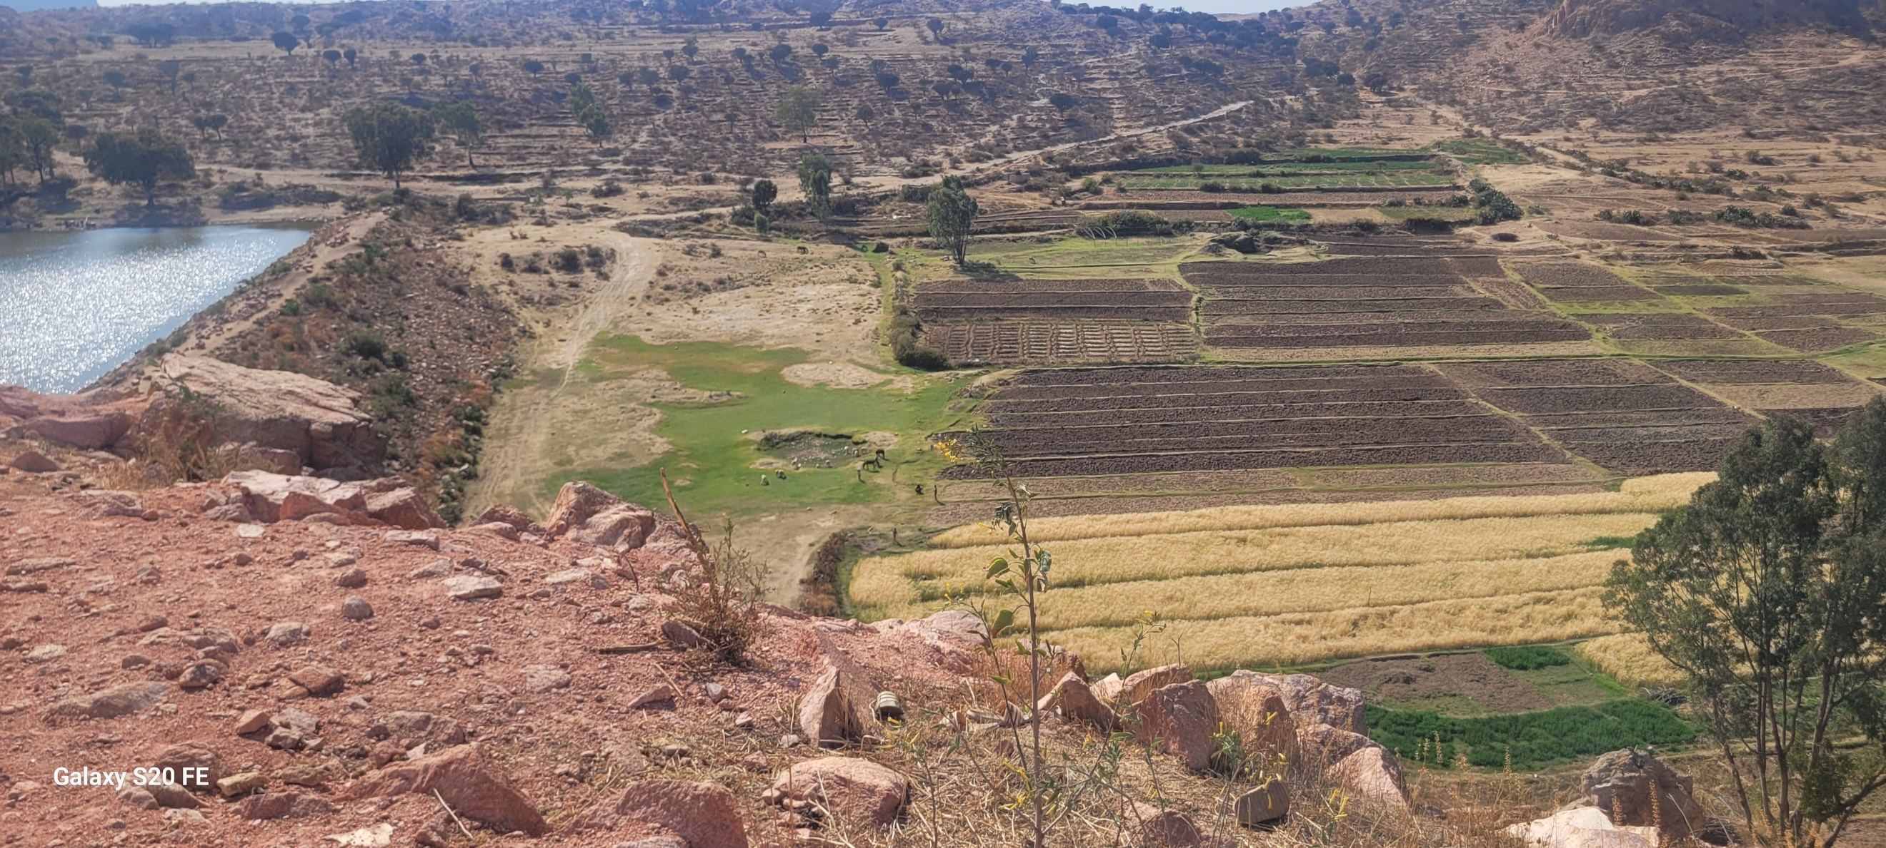
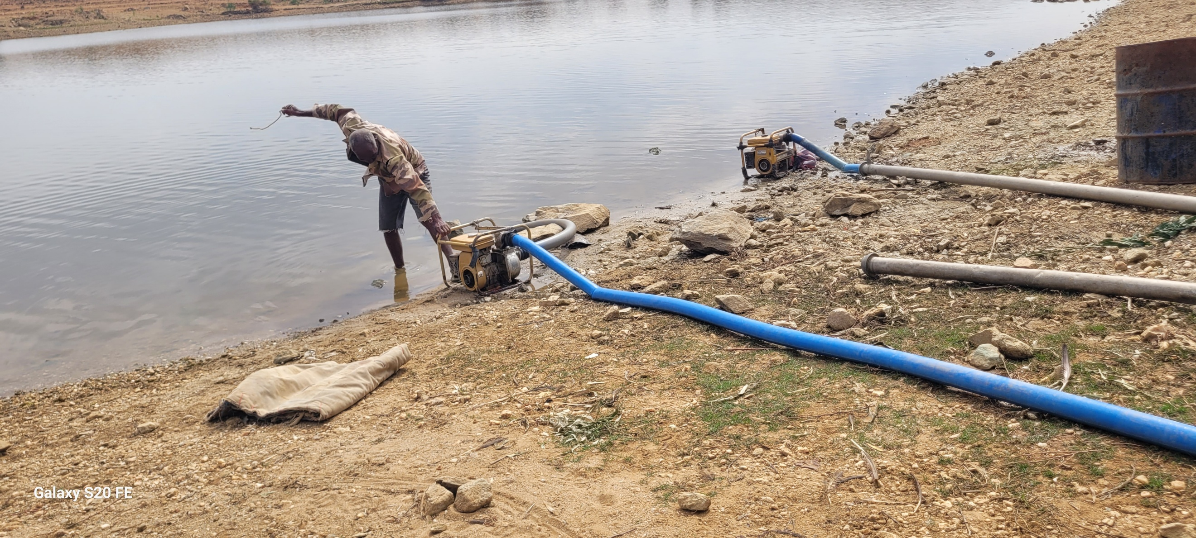
Project Title: SUSTAINABLE SMALLHOLDER IRRIGATED AGRICULTURE IN ARID AND SEMI-ARID LANDS IN MAEKEL, ANSEBA AND GASH-BARKA REGIONS, ERITREA

TABLE OF CONTENTS
1. Background and Introduction 1
1.1. Background 1
1.2. Introduction 1
2. Project Overview 2
2.1. Project Rationale and Objective 2
2.2. Geographic Scope and Target Beneficiaries 2
2.3. Project Components, Outcomes and Outputs 3
2.4. Expected Outcomes and Development Impact 3
2.5. Alignment with National Priorities and Global Frameworks 4
2.6. Project Implementation Timeline and Milestones 4
3. Progress During Inception Period 4
3.1. Overview of Inception Phase Activities 4
3.2. Stakeholder Mobilization and Consultation Process 5
3.3. Validation of Field Conditions and Technical Assumptions 5
3.4. Inception Mini workshops/Community engagement at Site Level 6
3.5. Review and Validation of the Draft Annual Work Plan (AWP) 6
3.6. Institutional Readiness and WUA Status 7
3.7. Progress in Project Organization and Coordination 7
3.8. Key Achievements of the Inception Period 7
4. Situation Analysis 7
4.1. Overview 7
4.2. Validity of Project Assumptions 8
4.3. Adequacy of Project Strategy 8
4.4. Emerging Risks and Threats 9
4.5. Emerging Opportunities and Synergies 10
4.6. Alternative Approaches and Design Adjustments 10
4.7. Implications for Project Implementation 11
5. Overview of the Project Implementation Process 11
5.1. Introduction 11
5.2. Annual Work Plan (AWP) for Year 1 11
5.3. Project Organization Structure and Governance 13
5.4. Monitoring and Evaluation (M&E) Framework 13
5.5. Project Risk Management 14
6. Social and Environmental Safeguards 15
6.1. Introduction 15
6.2. Key Environmental Considerations 15
6.3. Key Social Considerations 16
6.4. Occupational Health and Safety Considerations 17
6.5. Social and Environmental Risk Management Approach 17
6.6. Integration of Safeguards into Project Implementation 17
7. Gender Mainstreaming 18
7.1. Introduction 18
7.2. Gender Mainstreaming Approach 18
7.3. Gender Integration Across Project Components 19
7.4. Gender-Sensitive Targets and Indicators 19
7.5. Outcomes from Inception Mini workshops/Community engagement 19
7.6. Institutional and Implementation Measures 20
7.7. Contribution to National and Global Gender Commitments 20
8. Conclusions and Recommendations / Way Forward 21
8.1. Summary of Key Findings 21
8.2. Key Conclusions 22
8.3. Key Recommendations 23
8.4. Way Forward 23
8.5. Conclusion 24
Annex 1: Inception Mini-workshop Agenda (Site level) 25
Annex 2: Workshop Participants List 25
Annex 3: Endorsed Annual Work Plan and Budget for Year 1 26
Annex 4: Terms of Reference (TOR) for Conducting the Baseline Assessment (Attached) 30
Annex 5: Terms of Reference (TOR) for the Engineering Design of Solar-Powered, Gated-Pipe Irrigation (Attached) 30
Annex 6: Project Governance and Management Arrangements 1
Annex 7: Photographic Overview of the Nine Micro-dams 1

Background and Introduction

Background
The Ministry of Agriculture (MoA), in partnership with UNDP and AICS, is implementing a project to enhance climate-resilient smallholder agriculture through solar-powered semi-pressurized gated-pipe irrigation systems across nine sites in Eritrea’s arid and semi-arid regions.
These areas are characterized by low and highly variable rainfall, high evapotranspiration rates, and recurrent drought conditions, which together constrain reliable rainfed agricultural production. Climate variability has further intensified water scarcity, reduced crop productivity, and increased livelihood vulnerability among smallholder farming households. The proposed intervention responds to these challenges by promoting efficient, climate-resilient irrigation solutions that optimize limited water resources while reducing dependence on fossil fuel-based energy systems.
The project focuses on utilizing existing micro-dam infrastructure, with an estimated combined storage capacity of approximately 1.88 million cubic meters, to irrigate a total command area of approximately 225–315 hectares across nine sites. A fundamental design consideration is the balance between available stored water and seasonal crop water requirements, requiring careful integration of hydrological assessment, irrigation scheduling, and system efficiency to ensure sustainable abstraction and equitable water allocation.
Overall, the intervention integrates renewable energy, efficient water management, and user-managed distribution systems to improve agricultural productivity, enhance climate resilience, and strengthen rural livelihoods.

Introduction
This report consolidates the outcomes of inception mini workshops/community engagement conducted across all nine project sites between 25 and 28 February 2026, synthesized into a single report to ensure a unified understanding across implementation locations.
The workshops formally launched the project at local level and brought together community representatives, local administrators, sub-zoba officials, MoA extension agents, and subject matter specialists. They were designed to build shared understanding of objectives, outputs, implementation modalities, and institutional arrangements.
The consultations aimed to: (i) familiarize stakeholders with the project strategy and expected results; (ii) clarify roles and responsibilities of institutions, local authorities, WUAs, and communities; (iii) validate site-specific conditions and readiness; (iv) review the Draft Annual Work Plan (AWP) and implementation feasibility; and (v) engage beneficiaries and extension agents to assess farming systems and preferences and jointly determine the most appropriate irrigation technology (semi-pressurized gated-pipe or fully pressurized drip), based on feasibility, farmer capacity, and sustainability.
A key outcome was the consensus-based validation of the Draft AWP at each site, ensuring alignment with local agricultural calendars, water availability constraints, the selected irrigation technology (Solar-Powered Semi-Pressurized Gated-Pipe Irrigation Systems), and community priorities. Overall, the inception engagement established a strong foundation for project implementation, characterized by clear roles, high participation, and shared ownership of the initial work plan.

Project Overview

Project Rationale and Objective
The project “Sustainable Smallholder Irrigated Agriculture in Arid and Semi-Arid Lands in Maekel, Anseba and Gash-Barka Regions, Eritrea” has been designed to address systemic constraints in Eritrea’s agricultural sector, particularly the heavy reliance on rain-fed production systems, increasing climate variability, and limited access to reliable water resources. Agriculture remains the primary livelihood for a majority of the rural population, yet productivity is constrained by erratic rainfall, recurrent droughts, land degradation, and limited access to modern agricultural technologies and irrigation infrastructure.
Within this context, the project’s overarching objective is to enhance the resilience of smallholder farmers to climate change through the adoption of sustainable irrigated agriculture systems, thereby improving agricultural productivity, strengthening food and nutrition security, and promoting environmentally sustainable resource management.
The project adopts an integrated approach that combines solar-powered irrigation technologies, agroecological farming practices, and community-based water governance systems, ensuring that both technical and institutional dimensions of irrigation development are addressed simultaneously. This approach aligns with national development priorities, including the Agricultural Sector Strategic Development Plan and broader climate adaptation frameworks.

Geographic Scope and Target Beneficiaries
The project is implemented across nine selected sites distributed within three regions (Zobas):
- Maekel Region (six sites)
- Anseba Region (two sites)
- Gash-Barka Region (one site)
These sites were selected based on criteria including availability of water resources (micro-dams), agricultural potential, land suitability, and strong community willingness to participate in irrigation development.
Across the nine sites, the project will support irrigation development covering a combined command area of approximately 225-315 hectares, utilizing existing micro-dam systems with varying storage capacities.
The project directly targets:
- 1,120—2,000 smallholder farming households
- Approximately 4,621— 8,251 individuals
- With a strong emphasis on inclusion of women (including female-headed households), youth, and vulnerable groups
Women are recognized as key stakeholders in agricultural production, yet face structural barriers in access to land, water, and economic resources. The project therefore integrates gender-responsive approaches to ensure equitable access to irrigation services, training, and decision-making roles.

Project Components, Outcomes and Outputs
The project is structured around three interrelated components, each addressing critical dimensions of climate-resilient agricultural development.
Component 1: Agricultural Water Management
This component focuses on establishing sustainable, efficient, and equitable access to irrigation water through modernized systems and governance structures.
Key outputs include:
- Installation and operationalization of solar-powered irrigation systems
- Establishment and strengthening of Water Users Associations (WUAs)
The intervention introduces solar-powered pumping systems that reduce dependence on fossil fuels and unreliable electricity grids, improving energy access while lowering operational costs. At the same time, WUAs are established to enable community-led management of irrigation systems, ensuring equitable water allocation and system sustainability.
Component 2: Crop Productivity and Livelihood Improvement
This component aims to enhance agricultural production and diversify livelihoods through improved farming systems.
Key outputs include:
- Increased crop production and productivity through efficient irrigation and agroecological practices
- Improved livestock productivity through enhanced husbandry and fodder production systems
The project promotes climate-resilient agricultural practices such as crop diversification, soil and water conservation, and efficient irrigation management. These interventions are expected to increase yields, improve household incomes, and strengthen resilience to climate variability.
Component 3: Knowledge Management and Capacity Development
This component strengthens institutional capacity and facilitates learning and knowledge dissemination.
Key outputs include:
- Development of knowledge products and best practice documentation
- Establishment of a shared information system to support learning and replication
The project will document experiences and lessons learned from implementation sites to support scaling up and replication in similar agro-ecological zones across Eritrea.

Expected Outcomes and Development Impact
The project is expected to deliver integrated development outcomes across environmental, social, and economic dimensions.
Key expected outcomes include:
- Increased resilience of smallholder farmers to climate variability and shocks
- Improved access to reliable irrigation water and energy
- Increased agricultural productivity and diversification
- Enhanced food security and nutrition outcomes
- Strengthened community-level governance through functional WUAs
- Improved livelihoods and income generation opportunities
At the impact level, the project contributes to reducing rural poverty and improving adaptive capacity in the face of climate change, particularly in drought-prone and water-scarce environments.

Alignment with National Priorities and Global Frameworks
The project is fully aligned with Eritrea’s national development strategies and international development commitments.
At the national level, it supports:
- The Agricultural Sector Strategic Development Plan (2024–2028)
- National climate adaptation priorities and water resource management strategies
- Policies promoting irrigation development, food security, and rural livelihoods
At the global level, the project contributes directly to several Sustainable Development Goals (SDGs), including:
- SDG 2 (Zero Hunger): Increasing agricultural productivity and food security
- SDG 5 (Gender Equality): Promoting women’s participation and access to resources
- SDG 7 (Affordable and Clean Energy): Expanding renewable energy through solar irrigation
- SDG 8 (Decent Work and Economic Growth): Enhancing rural livelihoods
- SDG 13 (Climate Action): Strengthening climate resilience
- SDG 15 (Life on Land): Promoting sustainable land and natural resource management

Project Implementation Timeline and Milestones
The project has a planned duration of 36 months, from August 2025 to August 2028.
Key milestones include:
- Inception workshops and Inception Report (current phase)
- Finalization of Year 1 Annual Work Plan (AWP)
- Installation and operationalization of solar irrigation systems
- Establishment and operationalization of WUAs
- Periodic monitoring, annual reporting, and project reviews
- Mid-Term Review and Terminal Evaluation
The inception workshops/community enegagement represent a critical milestone in this timeline, marking the transition from project design to implementation and ensuring that all stakeholders share a common understanding of the project’s direction.

Progress During Inception Period

Overview of Inception Phase Activities
During the inception period, a comprehensive set of preparatory and engagement activities was undertaken to transition the project from design to implementation. Central to this process was the organization and conduct of inception workshops/community engagement activities at each of the nine project sites, alongside the preparation of comprehensive Terms of Reference for conducting socio-economic baseline assessments and the detailed engineering design of solar-powered semi-pressurized gated-pipe irrigation systems for nine smallholder farming communities. These activities were further complemented by a structured field mission and technical consultations with key stakeholders.
The field missions, together with the subsequent site-level inception mini-workshops/community engagement, enabled:
- Validation of site-specific field conditions and existing infrastructure
- Multi-level stakeholder engagement (community representatives, local authorities, MoA extension agents)
- Confirmation of strong community readiness and ownership
- Joint assessment of farming systems, water availability, and user preferences
- Selection of semi-pressurized gated-pipe systems as the most suitable irrigation technology based on efficiency, feasibility, farmer capacity, and long-term sustainability
- Alignment of technical design approaches with local conditions and realities
- Consolidation and participatory validation of the Annual Work Plan (AWP)

Stakeholder Mobilization and Consultation Process
A major achievement of the inception period was the successful mobilization and engagement of stakeholders across all project sites. Consultations were conducted with:
- Local farming communities (men and women)
- Village administrators and sub-zoba authorities
- MoA engineers, extension agents, and subject matter specialists
- Existing water committees and emerging Water Users Associations (WUAs)
Across all sites, stakeholders demonstrated:
- Strong interest in the project objectives
- High willingness to participate in implementation
- Clear understanding of challenges related to irrigation and water management

Validation of Field Conditions and Technical Assumptions
The inception phase provided an opportunity to validate key technical and contextual assumptions that underpin the project design.
Across all nine sites, a consistent pattern of constraints and opportunities was confirmed:
Key Constraints Identified
- Limited and unreliable access to irrigation water
- Absence or unreliability of electricity supply for pumping
- High operational costs for fuel-based irrigation systems
- Inefficient water distribution systems leading to prolonged irrigation cycles
- Institutional gaps in water management structures (absence or weak WUAs in several sites)
For example:
- At Geshnashim, irrigation cycles can take up to one week due to inefficient pumping systems
- At Guritat, lack of electricity severely limits irrigation potential
- At Deki Zeru, absence of electricity constrains agricultural productivity
Key Opportunities Confirmed
- Existence of micro-dams and infrastructure across all sites
- Significant potential to expand irrigated land
- Strong community engagement and investment in local infrastructure
- Presence of local knowledge and experience in irrigation practices

Inception Mini workshops/Community engagement at Site Level
Building on the field mission, inception mini workshops/community engagement were conducted at each project site to formally introduce the project and engage stakeholders in structured discussions.
The workshops covered:
- Presentation of project objectives, components, and expected results
- Explanation of solar-powered irrigation systems and proposed implementation approach
- Proposed Clarification of institutional arrangements and stakeholder roles
- Discussion of Water Users Association (WUA) establishment and strengthening
- Presentation and review of the Draft Annual Work Plan (AWP)
The workshops created a platform for:
- Open dialogue between project teams and local stakeholders
- Clarification of expectations and potential concerns
- Alignment of implementation timelines with local realities

Review and Validation of the Draft Annual Work Plan (AWP)
A critical output of the inception period was the presentation, discussion, and validation of the Draft Annual Work Plan (AWP) across all sites.
The AWP was reviewed in detail with stakeholders, including:
- Community representatives (men and women farmers)
- Local administrative authorities
- MoA extension agents and subject matter specialists
The discussions focused on:
- Sequencing and feasibility of Year 1 activities
- Alignment with local agricultural calendars
- Practical implementation timelines
- Roles and responsibilities in implementation
Key Outcome
The Draft AWP was formally validated and agreed at all project sites, ensuring that:
- Activities are aligned with site-specific conditions
- Implementation is feasible and realistic
- Responsibilities are clearly understood
- Communities are committed to participation

Institutional Readiness and WUA Status
The inception phase also assessed the status of local water governance structures.
Findings indicate varying levels of institutional readiness:
- Some sites (e.g., Geshnashim) have functional water committees already managing irrigation
- Other sites (e.g., Guritat, Himbirti) lack formal or operational WUAs
Stakeholders across all sites emphasized the importance of:
- Establishing or strengthening WUAs
- Developing clear governance rules and water allocation mechanisms
- Building capacity in operation, maintenance, and financial management

Progress in Project Organization and Coordination
During the inception phase:
- Roles of implementing partners (MoA, UNDP, regional administrations) were clarified
- Coordination mechanisms with local administrations were established
- Engagement pathways with communities and WUAs were initiated
At site level, the consultations confirmed that:
- Local administrations are ready to support implementation
- Community structures are willing to mobilize labour and participate
- Extension services are positioned to support training and capacity-building

Key Achievements of the Inception Period
The inception phase delivered a set of integrated achievements across technical, institutional, operational, and social dimensions:
- Technical: Validation of site conditions and confirmation of solar irrigation feasibility; selection of appropriate irrigation technology
- Institutional: Clarification of roles and initial assessment of WUA capacity
- Operational: Validation of the AWP and alignment of implementation timelines
- Social: Strong stakeholder engagement, participation, and community ownership
Overall, the inception phase has established a robust foundation for project implementation, characterized by:
- Alignment between project design and local needs
- High stakeholder readiness and commitment
- Confirmed feasibility of technical interventions
- Full validation of the first-year Annual Work Plan
The project is therefore well-positioned to proceed to detailed design and implementation, supported by strong technical, institutional, and operational readiness.

Situation Analysis

Overview
The situation analysis undertaken during the inception phase examined the continued validity of the project’s underlying assumptions, the adequacy of the proposed intervention strategy, and the evolving context at site and institutional levels. This analysis draws on evidence from:
- The project design and approved documentation
- UNDP–MoA joint field mission
- Site-level inception mini-workshops and stakeholder consultations
The findings confirm that the project remains highly relevant, technically feasible, and strongly supported by stakeholders, while also highlighting critical risks and opportunities that must be incorporated into implementation.

Validity of Project Assumptions
The original project design is based on a set of key assumptions related to water availability, community participation, institutional capacity, and adoption of improved technologies.
Assumptions Confirmed as Valid
1. Availability of Water Resources
The project assumes that sufficient water exists to support irrigation through micro-dams. Field verification confirms that all project sites have existing micro-dam infrastructure, with significant storage capacity and potential for irrigation expansion.
However, utilization remains sub-optimal due to technical (lack of irrigation facilities and reliable energy access) and management constraints rather than lack of water resources.
2. Strong Community Willingness to Participate
The assumption that communities are willing to engage in irrigation development is strongly validated. Across all sites, stakeholders expressed:
- High demand for irrigation services
- Willingness to contribute labour and participate in management
- Strong ownership of existing infrastructure
3. Technical Feasibility of Solar-Based Irrigation Systems
The project assumes that solar-powered irrigation systems are a viable alternative to fuel-based or grid-dependent systems. This assumption is confirmed by:
- Persistent electricity shortages across sites
- High cost of diesel-based pumping
- Favourable solar conditions
4. Institutional Potential for WUA Formation
Although not all sites have established WUAs, stakeholder consultations confirmed a strong willingness to establish and operationalize these structures. Existing water committees in some sites provide a foundation for scaling institutional arrangements.

Adequacy of Project Strategy
The project strategy combines three core elements:
- Solar-powered irrigation systems
- Semi-pressurized water distribution
- Community-based management through WUAs
Strengths of the Strategy
The inception phase confirms that this integrated approach is appropriate and well-aligned with field realities.
1. Addressing Core Constraints]
The strategy directly targets the two major bottlenecks identified across all sites:
- Water access and management (robust WUAs)
- Energy constraints
By integrating solar pumping with efficient distribution systems, the project provides a structural solution rather than incremental improvement.
2. Leveraging Existing Infrastructure
The approach builds on existing micro-dams and partially developed irrigation systems, ensuring cost-effectiveness and faster implementation.
3. Integration of Technical and Institutional Components
The integration of Water Users Associations (WUAs) alongside infrastructure development ensures that the project establishes systems that are both technically robust and institutionally sustainable.
4. Alignment with Agroecological Principles
The strategy promotes water-use efficiency, renewable energy, crop diversification, and soil management, contributing to long-term sustainability and resilience.
The strategy is fully adequate and remains appropriate. However, its success depends on:
- Strong sequencing between infrastructure and institution-building
- Intensive capacity-building support
- Adaptive management based on site-specific conditions

Emerging Risks and Threats
The inception phase identified several risks that may affect implementation. These risks are consistent with those outlined in the project design but are now further contextualized.
1. Water Resource Sustainability Risk
- Risk of over-abstraction from micro-dams
- Seasonal variability and competing water uses
Implication: Requires development of water management plans and strict abstraction control mechanisms.
2. Technical and Operational Risks
- Potential failure of solar systems due to poor maintenance
- Sedimentation and debris affecting intake structures
- Hydraulic inefficiencies in distribution systems
Implication:
Design must include:
- Robust engineering standards
- O&M protocols
- Local technical capacity development
3. Institutional and Governance Risks
- Weak or absent WUAs in some sites
- Risk of inequitable water distribution
- Potential for conflicts among users
Implication: Institutional strengthening is not optional and must be treated as a core project output.
4. Climate Variability Risk
- Increasing drought frequency
- Irregular rainfall patterns
Implication: Systems must be designed for water-use efficiency and resilience, including adaptive irrigation scheduling.
5. Socioeconomic and Inclusion Risks
- Limited participation of women if not proactively addressed
- Affordability challenges for O&M contributions
Implication: Requires gender-responsive design and inclusive governance frameworks.

Emerging Opportunities and Synergies
The inception phase also identified several opportunities that can strengthen project impact.
1. High Community Ownership
Existing investments in micro-dams and infrastructure demonstrate strong local commitment. This creates favourable conditions for sustainability.
2. Opportunity for Productivity Transformation
Transition from rain-fed to irrigated agriculture can:
- Increase cropping intensity
- Enable diversification into high-value crops
- Improve household incomes
3. Institutional Development Opportunity
The project provides a platform to establish model WUAs, which can be scaled nationally.
4. Renewable Energy Transition
Solar irrigation provides an opportunity to reduce:
- Dependence on fossil fuels
- Exposure to fuel price volatility
5. Knowledge Generation and Scaling
The nine sites offer diverse agroecological conditions, creating an opportunity to:
- Generate comparative learning
- Develop scalable irrigation models for Eritrea

Alternative Approaches and Design Adjustments
The inception phase confirmed that the core project approach remains appropriate. However, it highlighted the need for practical adjustments rather than strategic redesign.
Key Adjustments Identified
- Tailored WUA development approaches (site-specific)
- Flexible irrigation block design aligned with solar pumping cycles
- Phased implementation in sites with weaker institutional readiness
- Inclusion of infrastructure rehabilitation where needed
These adjustments align with the principle of adaptive management, allowing the project to respond to site-specific realities without altering its overall objective.

Implications for Project Implementation
The situation analysis leads to several critical implications:
Technical
- Designs must integrate water balance, hydraulic performance, and solar energy variability
- Emphasis on durability, simplicity, and maintainability
Institutional
- WUA establishment and capacity-building must be prioritized early
- Governance structures must ensure equity and transparency
Operational
- AWP implementation must be flexible and context-sensitive
- Strong coordination between technical and social components is required
The situation analysis confirms that the project is:
- Technically viable
- Socially supported
- Strategically aligned with national priorities
The core assumptions remain valid, and the project strategy is appropriate. However, successful implementation will depend on integrating adaptive management, strong institutional development, and context-specific design adjustments.
The insights generated during the inception phase significantly strengthen the project’s readiness for the next phase, ensuring that implementation is both evidence-based and locally grounded.

Overview of the Project Implementation Process

Introduction
The inception phase enabled the definition and confirmation of the project implementation framework, translating the approved project design into operational arrangements for Year 1 and beyond. This section outlines:
- The validated Annual Work Plan (AWP) for Year 1
- The project organization and governance structure
- The monitoring and evaluation (M&E) framework and reporting arrangements
- The updated risk management approach and mitigation measures
The Inception Mini-workshops played a central role in ensuring that these elements are aligned with field realities, stakeholder expectations, and institutional capacities, thereby providing an operationally feasible and implementation-ready framework.

Annual Work Plan (AWP) for Year 1
Overview and Validation
In line with UNDP requirements, the first-year Annual Work Plan (AWP) was presented, discussed, and validated during the inception mini workshops/community engagement at all project sites.
Key Priority Activities for Year 1
The validated AWP prioritizes foundational activities required to initiate implementation under all three project components.
Component 1: Agricultural Water Management
- Conduct baseline assessments of water resources, irrigation demand, and system requirements
- Undertake detailed engineering design of solar-powered irrigation systems
- Initiate procurement and installation planning for solar pumping and distribution infrastructure
- Develop site-specific water management plans (allocation rules, irrigation scheduling, O&M procedures)
- Establish and/or strengthen Water Users Associations (WUAs)
- Deliver training on:
  - Solar irrigation system operation and maintenance
  - Efficient water use and irrigation practices
Component 2: Crop Productivity and Livelihood Improvement
- Establish baseline data on crop production, water use, and socio-economic indicators
- Initiate farmer training programmes on:
  - Climate-smart agriculture
  - Crop diversification and high-value crops
  - Soil and water conservation techniques
- Begin provision of agricultural inputs (seeds, tools) for demonstration activities
- Establish field demonstration plots for crop and fodder production
Component 3: Knowledge Management and Capacity Development
- Develop a comprehensive capacity-building strategy and training plan
- Initiate documentation of baseline conditions and good practices
- Establish systems for data collection and knowledge management
- Begin preparatory work for knowledge-sharing platforms and communication materials
Financial Framework
The indicative allocation for Year 1 implementation is based on the multi-year project budget and focuses on:
- Capital investment in irrigation infrastructure
- Capacity development and training
- Baseline assessments and technical studies
- Project coordination, monitoring, and visibility
Budget execution will follow UNDP financial procedures, including:
- Annual work planning and budget approval
- Financial reporting and monitoring
- Audit and compliance requirements

Project Organization Structure and Governance
Implementation Modality
The project is implemented under National Implementation Modality (NIM), with:
- Ministry of Agriculture (MoA) as the Implementing Partner
- UNDP providing oversight, quality assurance, and technical support
This arrangement ensures national ownership, while maintaining compliance with UNDP operational standards.
Governance Structure
The project governance system includes multiple levels:
1. Project Steering Committee (PSC)
- Provides strategic oversight and decision-making
- Reviews and approves annual work plans, budgets, and reports
- Ensures coordination across institutions
Key members include:
- MoA (Chair)
- Ministry of Finance and National Development (MoFND)
- Ministry of Land, Water and Environment (MoLWE)
- Local governments of the zobas Maekel, Anseba, and Gash-Barka
- UNDP
2. Project Management Unit (PMU)
- Responsible for day-to-day project implementation
- Ensures delivery of outputs within time and budget
- Coordinates technical, administrative, and field operations
3. Regional and Local Implementation Structures
- Zoba and sub-zoba administrations support local implementation
- Provide coordination with communities and local institutions
4. Water Users Associations (WUAs)
- Community-based structures responsible for:
  - Water allocation and irrigation management
  - Operation and maintenance of irrigation systems
  - Conflict resolution and cost recovery
Roles and Responsibilities
The inception phase clarified roles across stakeholders:
- MoA: Overall implementation, coordination, and technical leadership
- UNDP: Oversight, quality assurance, compliance, and technical support
- Local administrations: Facilitation, coordination, and community engagement
- WUAs: System management and sustainability at community level

Monitoring and Evaluation (M&E) Framework
M&E Approach
The project adopts a results-based monitoring and evaluation framework, aligned with UNDP requirements.
Monitoring will focus on:
- Progress against output and outcome indicators
- Performance of irrigation systems and WUAs
- Agricultural productivity and livelihood improvements
- Gender and inclusion outcomes
Key M&E Activities
- Regular progress monitoring against results indicators
- Field visits and site inspections
- Annual project reporting
- Project Steering Committee reviews
- Mid-Term Review (MTR) and Terminal Evaluation (TE)
Data Collection and Reporting
Data collection will be supported through:
- WUA records and water management plans
- Farmer and household surveys
- Training attendance and performance tracking
- Engineering and installation reports

Project Risk Management
Risk Re-assessment
The inception phase enabled an updated assessment of risks, building on the project design.
Key risks include:
- Climate variability affecting water availability
- Technical failures or maintenance challenges
- Weak institutional capacity in WUAs
- Social and equity risks in water access
Risk Mitigation Measures
The following mitigation measures are incorporated into implementation:
- Development of water management plans to ensure sustainable abstraction
- Strong emphasis on operation and maintenance training
- Early establishment and strengthening of WUAs
- Inclusive participation and gender-responsive governance
- Continuous monitoring and adaptive management
Adaptive Management
The project will apply adaptive management principles, allowing:
- Adjustment of activities based on field performance
- Refinement of technical designs as needed
- Response to emerging risks and opportunities
This ensures flexibility while maintaining alignment with project objectives.
The inception phase has resulted in a fully structured and validated implementation framework, including:
- A realistic and stakeholder-endorsed Year 1 Annual Work Plan
- Clearly defined institutional roles and governance arrangements
- A robust monitoring and evaluation system
- An updated and practical risk management framework
This integrated implementation structure ensures that the project is:
- Operationally ready
- Institutionally anchored
- Technically sound
- Aligned with stakeholder priorities
The project is therefore well-positioned to proceed to the detailed design and implementation stage, with strong foundations for efficiency, accountability, and long-term sustainability.

Social and Environmental Safeguards

Introduction
The project integrates social and environmental safeguards as a core component of its implementation framework, ensuring that all activities are carried out in a manner consistent with the UNDP Social and Environmental Standards (SES). These safeguards were introduced and discussed during the inception mini workshops/community engagement to ensure that stakeholders understand their relevance and their implications for project design and implementation.
The safeguards framework aims to:
- Prevent and mitigate potential environmental and social risks
- Promote equitable access to project benefits
- Ensure sustainability of natural resources
- Strengthen community resilience and inclusion
During the inception mini-workshops, stakeholders were sensitized on the importance of adhering to safeguard requirements, particularly in relation to water resource management, infrastructure development, community participation, and environmental sustainability.

Key Environmental Considerations
Sustainable Water Resource Management
The project relies on micro-dams as the primary water source for irrigation. While these represent a significant opportunity, they also introduce risks related to over-abstraction and resource depletion.
Field consultations confirmed that water availability varies seasonally and that existing systems are not always managed sustainably.
Safeguard Measures:
- Development of site-specific water management plans, including abstraction limits and allocation rules
- Integration of irrigation scheduling aligned with solar pumping cycles and water availability
- Continuous monitoring of water levels and seasonal drawdown patterns
These measures ensure that irrigation development remains within sustainable limits and does not compromise long-term water availability.
Climate Resilience and Environmental Sustainability
Eritrea’s agricultural systems are highly vulnerable to climate variability, including drought and extreme weather events.
The project integrates climate-resilient approaches to ensure long-term sustainability.
Safeguard Measures:
- Promotion of water-efficient irrigation technologies
- Integration of agroecological practices (soil conservation, crop diversification)
- Design of irrigation systems that can adapt to variable water availability
These measures support broader environmental goals, including land rehabilitation and ecosystem protection.

Key Social Considerations
Inclusive Participation and Equity
The project is designed to ensure inclusive participation of all stakeholder groups, with particular attention to women, youth, and vulnerable households. However, structural inequalities—particularly in access to productive resources, including irrigation water—continue to pose a significant challenge within the broader socio-economic context.
Safeguard Measures:
- Ensuring representation of women in Water Users Associations (WUAs)
- Providing equal access to training and capacity-building activities
- Promoting transparent and equitable water allocation mechanisms
Community Engagement and Ownership
A key principle of the project is community ownership of irrigation systems, which is essential for sustainability.
Field consultations demonstrated strong community commitment but also highlighted the need for formal structures to manage collective resources effectively.
Safeguard Measures:
- Establishment and strengthening of WUAs
- Development of governance frameworks (rules, by-laws, roles)
- Continuous engagement through community meetings and participatory decision-making
Livelihood Protection and Enhancement
The project is expected to generate positive social impacts by:
- Increasing agricultural productivity
- Improving household incomes
- Enhancing food and nutrition security
However, safeguards are required to ensure that these benefits are distributed equitably and do not create unintended conflicts.
Safeguard Measures:
- Transparent beneficiary selection and participation processes
- Monitoring of benefit distribution across gender and socioeconomic groups
- Integration of conflict resolution mechanisms within WUAs

Occupational Health and Safety Considerations
The implementation of solar-powered irrigation systems and associated infrastructure introduces occupational health and safety (OHS) risks, particularly during installation and maintenance.
Key Risks:
- Electrical hazards from solar systems
- Physical risks during installation of pumps and pipelines
- Handling of equipment and materials
Safeguard Measures:
- Training for local technicians and operators on safe installation and maintenance
- Use of appropriate protective equipment
- Development of basic safety protocols at site level
These measures are critical to ensuring safe and sustainable system operation.

Social and Environmental Risk Management Approach
Risk Identification and Monitoring
The project will utilize a structured approach to identify, monitor, and manage social and environmental risks, including:
- Regular updating of the risk log
- Integration of safeguard monitoring into routine project supervision
- Periodic assessments of environmental and social impacts
Adaptive Management
Consistent with UNDP principles, the project will apply adaptive management, enabling adjustments based on:
- Field performance
- Stakeholder feedback
- Emerging risks and opportunities
This ensures that safeguard measures are effectively maintained throughout the implementation period.
Grievance and Accountability Mechanisms
Stakeholders were informed during the inception mini workshops/community engagement about the importance of accountability and grievance redress mechanisms.
The project will ensure:
- Accessible channels for communities to raise concerns
- Transparent handling of complaints
- Integration with UNDP’s broader accountability mechanisms

Integration of Safeguards into Project Implementation
Safeguards are not treated as standalone measures but are integrated into all aspects of project implementation:
- Design stage: Incorporation of environmental and social considerations into engineering and institutional design
- Implementation stage: Continuous monitoring and adaptation
- Institutional level: Capacity-building of WUAs and local stakeholders to manage risks
This integrated approach ensures that safeguards contribute to both risk mitigation and long-term sustainability.
The inception phase confirmed that while the project has strong potential to deliver significant environmental and social benefits, proactive implementation of safeguards is essential to ensure sustainability and equity.
Key conclusions include:
- Environmental risks related to water use and infrastructure can be effectively managed through design and monitoring
- Social risks related to equity and governance require strong institutional arrangements
- Stakeholder awareness of safeguards has been initiated and must be sustained through capacity-building
Overall, the project is well-positioned to implement its safeguard framework, ensuring that development outcomes are achieved in a sustainable, inclusive, and responsible manner.

Gender Mainstreaming

Introduction
Gender equality and women’s empowerment are central to the design and implementation of the project. The project is classified with a Gender Marker 2, indicating that gender equality is a significant objective, and therefore requires systematic integration across all components, outputs, and implementation arrangements.
The inception phase, including site-level mini-workshops and stakeholder consultations, confirmed that while women play a critical role in agricultural production, they continue to face structural constraints in access to:
- Land and productive assets
- Irrigation water and agricultural inputs
- Decision-making platforms and governance structures
- Training and extension services
The project therefore adopts a gender-responsive approach, ensuring that women are not only beneficiaries but also active participants and decision-makers in irrigation development and agricultural transformation.

Gender Mainstreaming Approach
The project integrates gender equality across technical, institutional, and capacity-building dimensions, ensuring that gender considerations are embedded throughout implementation.
Gender-Responsive Design Principles
The following principles guide project implementation:
- Equal access: Ensure women have equitable access to irrigation water, training, and inputs
- Participation: Promote women’s meaningful participation in WUAs and decision-making processes
- Capacity development: Strengthen women’s technical and managerial skills
- Benefit equity: Ensure fair distribution of project benefits
- Empowerment: Support women’s leadership and economic participation

Gender Integration Across Project Components
Component 1: Agricultural Water Management
Gender integration focuses on ensuring equitable access and participation in water management systems.
Key Measures:
- Inclusion of women as members and leaders in Water Users Associations (WUAs)
- Participation of women in development of water allocation rules and irrigation schedules
- Targeted training for women on:
  - Irrigation system operation and maintenance
  - Water management practices
Component 2: Crop Productivity and Livelihood Improvement
This component directly contributes to improving women’s livelihoods and economic empowerment.
Key Measures:
- Targeted training for women in:
  - Climate-smart agriculture
  - Crop diversification and high-value crops
- Support for women’s participation in demonstration plots and production activities
- Improved access to inputs (seeds, tools) for female farmers
Component 3: Knowledge Management and Capacity Development
Gender-responsive knowledge management ensures inclusive learning and replication.
Key Measures:
- Development of gender-responsive knowledge products
- Inclusion of women in training, learning events, and knowledge-sharing platforms
- Documentation of women-led best practices and success stories

Gender-Sensitive Targets and Indicators
To ensure accountability, the project incorporates gender-disaggregated indicators and targets, including:
- At least 25% of direct beneficiaries are women, including female-headed households
- Participation of women in WUAs and water governance structures
- Number of women trained in:
  - Irrigation technologies
  - Agricultural practices
- Percentage of women with equitable access to irrigation water
These indicators will be tracked through the project M&E system, ensuring measurable progress toward gender equality outcomes.

Outcomes from Inception Mini workshops/Community engagement
The inception mini-workshops revealed several important gender-related insights:
Positive Findings
- Active participation of women in community-level consultations
- Strong interest in irrigation systems and improved agricultural production
- Recognition of women’s role in household food security and farm management
Challenges Identified
- Limited representation of women in existing water committees
- Potential barriers to participation in decision-making due to social norms
- Limited access to technical training and extension services
Implications for Implementation
- Gender inclusion must be proactively facilitated, not assumed
- WUA establishment must include minimum thresholds for women’s participation
- Training programmes must be accessible and tailored to women’s needs

Institutional and Implementation Measures
To operationalize gender mainstreaming, the project will implement:
1. Inclusion in Governance Structures
- Ensure women are represented in WUAs at both membership and leadership levels
- Promote gender-balanced decision-making structures
2. Gender-Responsive Capacity Building
- Design training schedules that accommodate women’s availability
- Provide targeted technical and leadership training for women
3. Monitoring and Reporting
- Collect and report sex-disaggregated data
- Track women’s participation, access, and benefits
4. Partnerships and Social Mobilization
- Engage local structures (e.g., women’s associations where applicable)
- Promote awareness on gender equality and inclusive participation

Contribution to National and Global Gender Commitments
The project contributes to:
- Eritrea’s Gender Equality Strategy (2022–2025)
- National priorities on inclusive agricultural development
- SDG 5 (Gender Equality), particularly:
  - Equal access to economic resources
  - Enhanced participation in decision-making
  - Access to enabling technologies
The inception phase confirmed that gender equality is both a critical need and a key opportunity for the project.
While women are actively involved in agricultural activities, achieving equitable outcomes requires targeted, structured, and sustained interventions.
The project is therefore well-positioned to:
- Enhance women’s access to irrigation and productive resources
- Strengthen women’s participation in governance and decision-making
- Improve livelihoods and resilience for female farmers
Through its integrated approach, the project will contribute to transformational gender outcomes, ensuring that irrigation development is not only technically effective but also socially inclusive and equitable.

Conclusions and Recommendations / Way Forward

Summary of Key Findings
1. High Relevance and Strategic Alignment
The project directly addresses core constraints in the agricultural sector, including:
- Limited access to irrigation water
- High dependence on rain-fed agriculture
- Energy constraints for water pumping
- Weak institutional arrangements for water management
The integrated approach combining solar-powered irrigation, agroecological practices, and WUA-based governance is confirmed to be appropriate and aligned with both national priorities and community needs.
2. Strong Stakeholder Ownership and Readiness
Stakeholder engagement across all nine sites demonstrated:
- Strong community willingness to participate
- Commitment from local administrations
- Active involvement of MoA extension services
The formal validation and agreement of the Draft Annual Work Plan (AWP) across all sites represents a major milestone, ensuring local ownership and implementation feasibility.
3. Technical Feasibility Confirmed
Field assessments validated that:
- Existing micro-dams provide a strong foundation for irrigation
- Solar-powered irrigation systems are technically appropriate
- Significant potential exists to improve irrigation efficiency and expand productivity
At the same time, site-specific technical adjustments are required to address issues such as:
- Dam maintenance gaps
- Sedimentation and intake protection
- Hydraulic inefficiencies in distribution systems
4. Institutional Gaps Identified
While some sites have functioning water committees, others lack formal governance structures.
The success of the project will depend heavily on:
- Establishment and operationalization of Water Users Associations (WUAs)
- Strengthening governance systems for water allocation, O&M, and conflict resolution
5. Gender and Inclusion Opportunities
The inception phase confirmed:
- Strong participation of women in consultations
- Continued structural barriers to access and decision-making
The project has strong potential to achieve transformational gender outcomes, provided that gender-responsive measures are implemented effectively.
6. Risks and Mitigation Measures Identified
Key risks include:
- Climate variability affecting water availability
- Technical and maintenance challenges
- Institutional weaknesses in WUAs
- Potential inequities in water access
These risks are manageable through:
- Proper design and planning
- Strong capacity-building interventions
- Continuous monitoring and adaptive management

Key Conclusions
Conclusion 1: Project Design Remains Fully Valid
The inception phase confirms that:
- The project objective, components, and outputs are valid and relevant
- No major revisions to the project strategy are required
However, minor adjustments at activity and implementation level are necessary to reflect site-specific conditions, consistent with adaptive management principles.
Conclusion 2: Implementation Readiness is High
The project is ready to proceed to implementation, supported by:
- Stakeholder agreement on the AWP
- Confirmed site conditions and feasibility
- Established coordination mechanisms
The transition from planning to implementation can proceed without delay.
Conclusion 3: Institutional Strengthening is Critical
Technical interventions alone will not guarantee sustainability.
The project must prioritize:
- Early establishment and strengthening of WUAs
- Development of governance systems
- Capacity-building for long-term operation and maintenance
Conclusion 4: Integrated Approach is Essential
The project’s success depends on maintaining strong integration between:
- Infrastructure development
- Institutional strengthening
- Capacity building
- Knowledge management
Implementation must avoid treating these components as separate, ensuring a holistic approach.

Key Recommendations
Technical Recommendations
- Finalize site-specific baseline assessment and engineering designs incorporating:
  - Socio-economic and farming systems
  - Water balance analysis
  - Hydraulic efficiency optimization
  - Intake protection and sediment management
- Integrate solar system sizing and irrigation scheduling to match real demand
Institutional Recommendations
- Establish or formalize WUAs at all sites as an early priority
- Develop clear governance frameworks including:
  - Membership rules
  - Water allocation mechanisms
  - Maintenance responsibilities
- Provide targeted training in:
  - Governance and financial management
  - Conflict resolution
  - Technical operation and maintenance
Gender and Inclusion Recommendations
- Set minimum participation thresholds for women in WUAs
- Ensure women’s inclusion in decision-making roles
- Tailor training and capacity-building activities to be accessible to women
- Monitor gender indicators regularly and adjust approaches as needed
Operational Recommendations
- Maintain strong coordination between technical and institutional activities
- Implement the AWP with flexibility, allowing adjustments based on field conditions
- Establish regular feedback mechanisms with communities to ensure responsiveness
Monitoring and Adaptive Management Recommendations
- Strengthen site-level data collection systems (WUA records, irrigation performance, training outputs)
- Regularly update the risk log and mitigation measures
- Use monitoring results to guide adaptive adjustments in implementation
Knowledge and Scaling Recommendations
- Document site-level experiences and best practices early
- Develop knowledge products to support replication and scaling
- Use the nine sites as learning platforms across agroecological zones

Way Forward
Immediate Next Steps (Post-Inception)
- Finalize detailed Socio-economic assessment and engineering designs for all sites
- Initiate procurement processes for solar irrigation systems
- Begin WUAs establishment and capacity-building activities
- Conduct baseline studies for agriculture, water use, and socio-economic indicators
- Launch initial training programmes for farmers, WUAs, and extension agents
Short-Term Implementation Priorities (Year 1)
- Rollout of agricultural productivity and training interventions
- Installation and commissioning of solar-powered irrigation systems
- Operationalization of WUAs
- Establishment of monitoring and knowledge management systems
Medium-Term Direction (Years 2–3)
- Consolidation of irrigation systems and governance structures
- Expansion of agricultural productivity gains
- Strengthening of knowledge systems and scaling pathways

Conclusion
The inception phase has successfully:
- Validated the project design
- Strengthened stakeholder ownership
- Established a realistic and agreed implementation framework
- Identified key risks, opportunities, and adjustments
The project is now fully ready to move into implementation, with strong prospects to deliver:
- Improved irrigation access and efficiency
- Increased agricultural productivity and livelihoods
- Enhanced climate resilience
- Sustainable and inclusive community-based water management
This positions the project as a flagship intervention for sustainable irrigated agriculture in Eritrea, with significant potential for scaling and long-term impact.

Annex 1: Inception Mini-workshop Agenda (Site level)
Project: Sustainable Smallholder Irrigated Agriculture in Arid and Semi-Arid Lands in Maekel, Anseba and Gash-Barka Regions, Eritrea
Workshop format: 1-day site inception workshop (repeatable across sites)
Participants: Beneficiary farmers (men and women), village/sub-zoba administrators, MoA extension agents, subject matter specialists, WUA/committee representatives, UNDP/MoA team
Agenda
Session | Purpose / Key Outputs
Introductions & Workshop Objectives | Introduce participants and confirm workshop objectives and expected outputs
Project Overview | Present project objectives, expected outputs, implementation approach and timelines
Institutional Arrangements & Roles | Clarify roles of MoA, UNDP, local administration, WUAs/communities; confirm coordination and responsibilities
Site Validation (Field Conditions & Readiness) | Validate site conditions, infrastructure status, water availability issues, and community readiness; confirm key assumptions
Irrigation Technology Options & Joint Selection | Discuss with beneficiaries and extension agents to determine the most appropriate irrigation option (semi-pressurized gated-pipe vs fully pressurized drip) based on feasibility, farmer capacity and sustainability
Draft Annual Work Plan (AWP) – Presentation | Present Year-1 draft AWP: activities, sequencing, timelines and feasibility at site level
AWP Discussion & Site-Level Inputs | Gather stakeholder feedback, confirm feasibility, roles, and site commitments; adjust sequencing where needed
Governance & WUA Strengthening | Discuss WUA/committee readiness, actions needed to establish/strengthen WUAs, and principles for equitable water allocation and O&M
Safeguards & Gender Mainstreaming (Brief) | Confirm inclusive participation (men/women), safeguards awareness, and basic compliance expectations during implementation
Agreements, Next Steps & Way Forward | Confirm key agreements: AWP validation status, selected irrigation technology option, next actions and timeline
Expected Workshop Outputs
- Shared understanding of the project objectives, outputs, and implementation approach
- Confirmed roles and responsibilities across MoA, UNDP, local administration, WUAs and communities
- Site-validated conditions, assumptions and readiness
- Participatory determination of the most appropriate irrigation option (gated-pipe vs drip)
- Draft AWP reviewed and validated with stakeholders at site level

Annex 2: Workshop Participants List
- Michael Berhane — Director, Natural Resources and Irrigation Development Division, MoA (HQ)
- Samsom Fessehatsion — Engineer, MoA (HQ)
- Abel Weldegabir — Engineer, MoA (Zoba Maekel)
- Adam Habteab — Programme Specialist, UNDP (UNDP)
- Yordanos Mehari — Programme Analyst, UNDP (UNDP)
- Yemane Tekeste — Executive Secretary (Geshnashim)
- Mussie Ghilay — Sub-zoba Engineer (Geshnashim)
- Alazar Tesfagabir — Village Administrator (Geshnashim)
- Issayas Mehari — Administration (Geshnashim)
- Mohamed Beri — Village Administrator (Guritat)
- Bekhit Idris — Village Administrator (Guritat)
- Mes’ud Abdelkadir — MoA Extension (Serejaka) (Guritat)
- Maekele — Farmer (Guritat)
- Saron Simon — MoA Extension (Deki Zeru)
- Henok Teklesembet — Farmer (Deki Zeru)
- Beshir Mohamed Saleh — Area Administrator (Aibaba)
- Ferej Jimee — Village Administrator (Aibaba)
- Seid Dirar — Administration (Aibaba)
- Fatna Bekit Mohamed — Gherger Administration (Aibaba)
- Tesfay Kesete — Administrator (Liban)
- Mussie Embaye — Executive Secretary (Liban)
- Askalu Yemane — Village Administrator (Liban)
- Yosief Brhane — Village Administrator (Liban)
- Eyasu Abraham — Development Committee Member (Liban)
- Tesfaldet Sereke — Development Committee Member (Liban)
- Alazar Ghebrehiwet — Administrator (Himbirti)
- Tekle Ghebremariam — Executive Secretary (Himbirti)
- Tesfay Semere — Economic Development Committee Member (Himbirti)
- Tekie Woldemariam — Area Administrator (Ametsi)
- Ainom Teklegergis — Executive Secretary (Ametsi)
- Adem Balga — Village Administrator (Ametsi)
- Hagos Hadgu — Village Administrator (Ametsi)
- Ferej Birhan — Water Committee Member (Ametsi)
- Yonas Tesfagabir — Water Committee Member (Ametsi)
- Redie Berhe — Water Committee Member (Ametsi)
- Petros Al’azar — Community Diesel-Powered Water Pump Operator (Ametsi)
- Kesete Fisehaye — Farmer (Irrigation) (Ametsi)
- Michael Tekeste — Agricultural Extension Agent (Ametsi)
- Tekeste Abraha — Area Administrator (Tse’azega)
- Hagos Habte — Village Administrator (Tse’azega)
- Nuguse Iyasu — Agricultural Extension Agent (Tse’azega)

Annex 3: Endorsed Annual Work Plan and Budget for Year 1
EXPECTED OUTPUTS | PLANNED ACTIVITIES | Planned Budget by Year and Source of Funding
EXPECTED OUTPUTS | PLANNED ACTIVITIES | AICS (€) | AICS ($)
EXPECTED OUTPUTS | PLANNED ACTIVITIES | Year1
EXPECTED OUTPUTS | PLANNED ACTIVITIES | AICS (€) | US$
Output1.1.1: Solar-powered irrigation systems implemented and operationalized. | Activity1.1.1.1: Conduct baseline assessments of local agricultural water resources, and farmers needs to develop suitable irrigation technologies, withdrawal practices and optimal water use. | 50,000.00 | 58,860.00
 | Activity1.1.1.2: Identify, design, and install suitable solar-powered irrigation systems. | 140,955.00 | 165,932.23
Gender marker:2 | Activity1.1.1.3: Training for farmers, extension agents and WUAs on solar-powered irrigation technologies, techniques, and efficient use of irrigation water. | 28,379.00 | 33,407.76
 | Activity1.1.1.4: Training sessions for farmers and extension agents on the operation and maintenance of solar irrigation systems. | 56,804.00 | 66,869.67
 | Activity1.1.1.5: Develop comprehensive water management plan that outlines water allocation, irrigation schedules, and maintenance activities. | - | -
 | MONITORING (including visibility) | 5,000.00 | 5,886.00
 | Sub-Total for Output1.1.1 | 281,138.00 | 330,955.65
Output1.1.2: Water Users Associations established and Operationalized. | Activity1.1.2.1: Conduct meetings and workshops to raise awareness of the befits of forming a WUA and gather input from community members about their water management concerns and ideas. | 4,257.00 | 5,011.34
 | Activity1.1.2.2: Develop constitution or set of bylaws that govern the WUA, detailing roles, responsibilities, decision-making process, and rules for membership and participation. | - | -
Gender marker:2 | Activity1.1.2.3: Establish community-managed Water Users Association with defined roles, responsibilities, and governance structure to manage and ensure equity in access to irrigation water. | - | -
 | Activity1.1.2.4: Training for extension agents, community leaders, WUAs and farmers on governance, conflict resolution, financial management and efficient water management practices to farmers, | - | -
 | MONITORING (including visibility) | 5,000.00 | 5,886.00
 | Sub-Total for Output1.1.2 | 9,257.00 | 10,897.34
Output2.1.1: Increased crop production and productivity through improved agricultural practices, efficient use of irrigation water and crop diversification. | Activity2.1.1.1: Establish a baseline of agricultural productivity, water use, and socio-economic indicators before project implementation. | - | -
 | Activity2.1.1.2: Training session for smallholder farmers and extension agents on cop diversification, nutritious crops (vegetables and fruits), farming systems, integrated pest management techniques and climate change adaptation agricultural practices. | 35,000.00 | 41,202.00
Gender marker:2 | Activity2.1.1.3: Training on soil and water conservation techniques, efficient irrigation water use, crop water management, pest management, and resource management. | - | -
 | Activity2.1.1.4: Provision of key agricultural materials and equipment |  | -
 | Procurement of Scientific Agricultural soils, water and geotechnical field instruments  "Soil moisture senser with Professional-grade sensors (Portable)"  "Professional-grade water analysis tools (Portable)"  "Soil Nutrient Analysis Tools (Portable)"  Double ring Infiltrometer (Portable)  Geophysics instrument for ground profiling and bedrock depth determination | 472,972.00 | 556,782.64
 | Activity2.1.1.5: Establish field learning demonstration plots for selected high value crops (vegetables and fruits). | - | -
 | MONITORING (including visibility) | - | -
 | Sub-Total for Output2.1.1 | 507,972.00 | 597,984.64
Output2.1.2: Increased animal production through improved husbandry and fodder production. | Activity2.1.2.1: Train farmers and extension agents on production of improved and drought and climate resilient of grasses, fodder, and forage and feed conservation. | 25,525.00 | 30,048.03
 | Activity2.1.2.2: Distribute drought and climate resilient seeds of grasses, fodder, and forage to support promotion of animal feed production among the smallholder famers. | - | -
Gender marker:2 | Activity2.1.2.3: Train farmers on animal health and improved husbandry. | 12,000.00 | 14,126.40
 | Activity2.1.2.4: Establish field learning demonstration plots for selected fodder and forage varieties. | 15,404.00 | 18,133.59
 | MONITORING (including visibility) | 5,000.00 | 5,886.00
 | Sub-Total for Output2.1.2 | 57,929.00 | 68,194.02
Output3.1.1: Knowledge generation products from the project areas developed and disseminated. | Activity3.1.1.1: Prepare a comprehensive capacity and training strategy and plan. | 10,000.00 | 11,772.00
 | Activity3.1.1.2: Hold workshops to demonstrate successful stories, best practices and lessons learnt from the programme implementation process. | - | -
Gender marker: 2 | Activity3.1.1.3: Host farmer tours, visits, and field days to showcase project best practices and success stories. | - | -
 | Activity3.1.1.4: Conduct periodic evaluations to assess the project’s impact on agricultural productivity, food and nutrition security and household income. | - | -
 | Activity3.1.1.5: Host community forums for information generation and dissemination | - | -
 | MONITORING (including visibility) | - | -
 | Sub-Total for Output3.1.1 | 10,000.00 | 11,772.00
Output3.1.2: A shared information system for documenting programme implementation process, information, best practices, and lessons learned is developed and implemented. | Activity3.1.2.1: Establish a depository system/forum to document all programme implementation reports and survey information. | 5,462.00 | 6,429.87
 | Activity3.1.2.2: Develop training materials for agricultural agents and local authorities on data/information, collection, documentation, use/dissemination. | - | -
Gender marker: 2 | Activity3.1.2.3: Produce gender-responsive agricultural information and communication for agricultural extension officers on agricultural, agro-forestry and ecosystem-based adaptation (EbA) | - | -
 | Activity3.1.2.4: Develop a gender-responsive CCA awareness and communication strategy for the project | - | -
 | MONITORING (including visibility) | - | -
 | Sub-Total for Output3.1.2 | 5,462.00 | 6,429.87
Programme operations including technical support |  | 45,000.00 | 52,974.00
PROGRAMMABLE TOTAL |  | 916,758.00 | 1,079,207.52
General Management Support (Project Management) |  | 83,242.00 | 97,992.48
TOTAL |  | 1,000,000.00 | 1,177,200.00

Annex 4: Terms of Reference (TOR) for Conducting the Baseline Assessment (Attached)

Annex 5: Terms of Reference (TOR) for the Engineering Design of Solar-Powered, Gated-Pipe Irrigation (Attached)

Annex 6: Project Governance and Management Arrangements
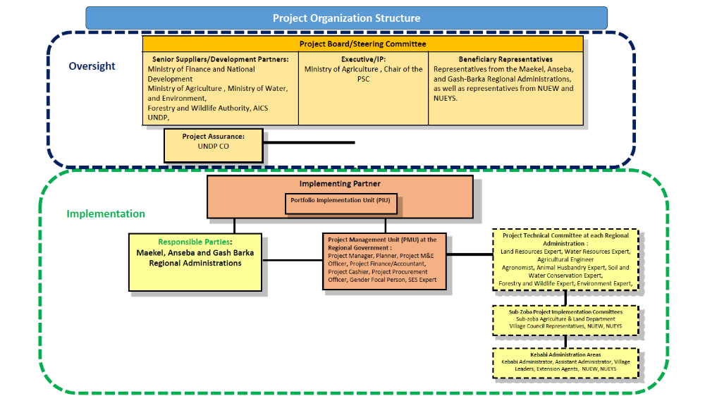

Annex 7: Photographic Overview of the Nine Micro-dams
Site 1: Geshnashim Micro Dam, estimated storage capacity 80,000m3, and ≈ 30 ha command areaZoba Maekel
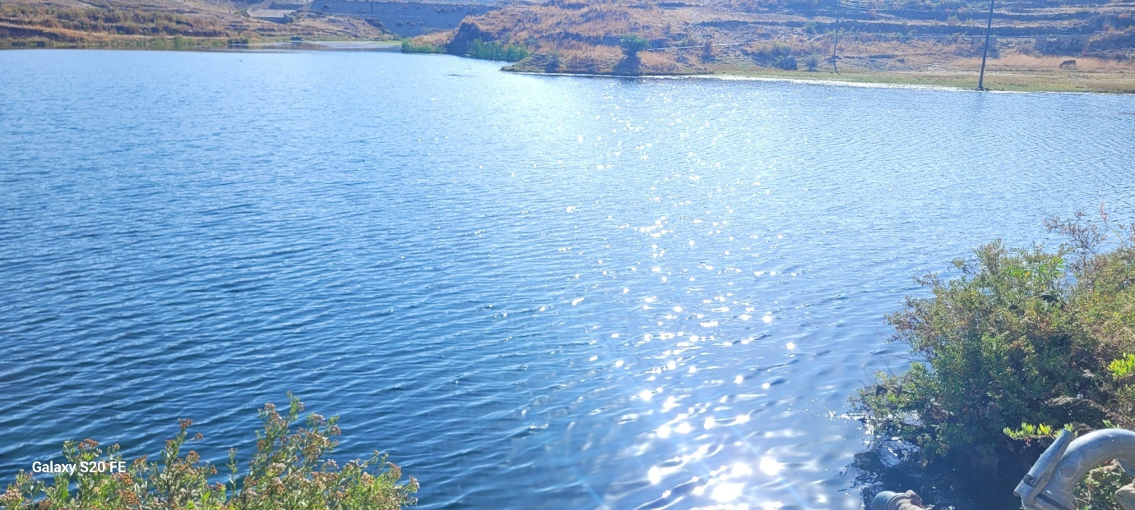
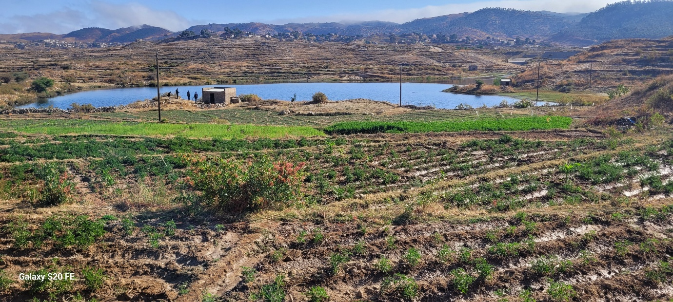
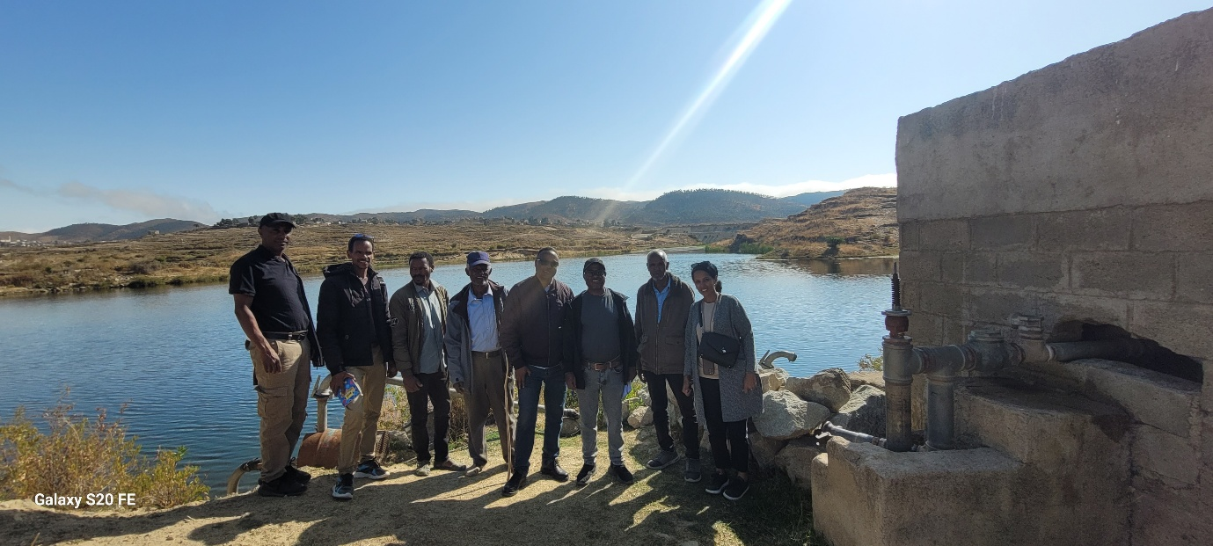
Site 2: Guritat Micro-dam, estimated storage capacity 300,000m³, and ≈ 35ha command area, Zoba Maekel
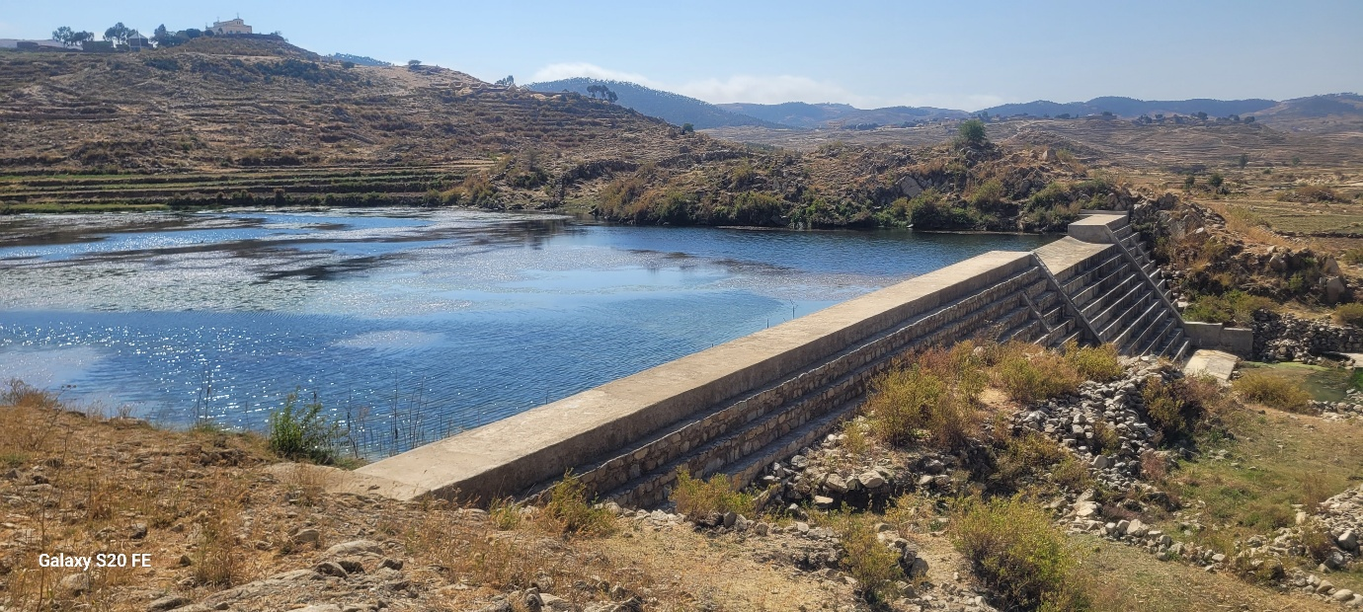
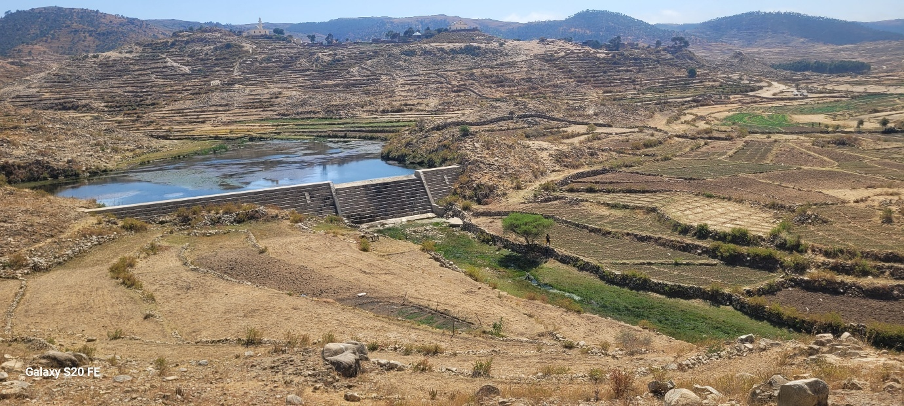
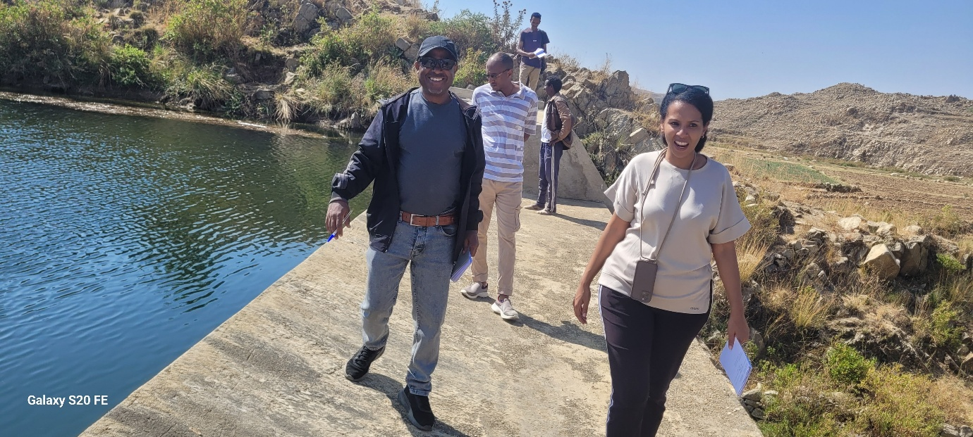
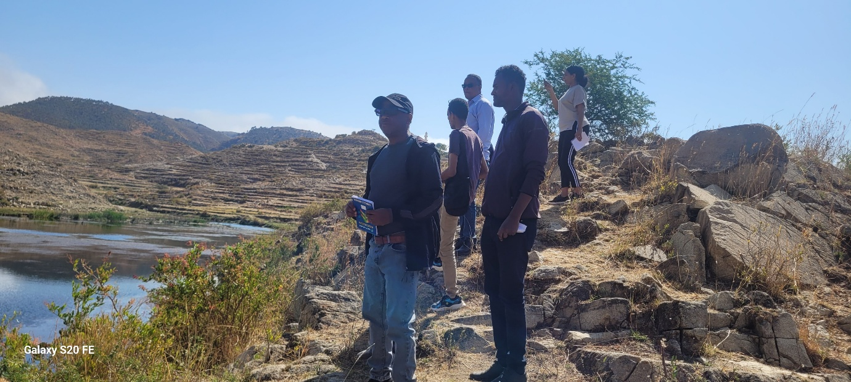
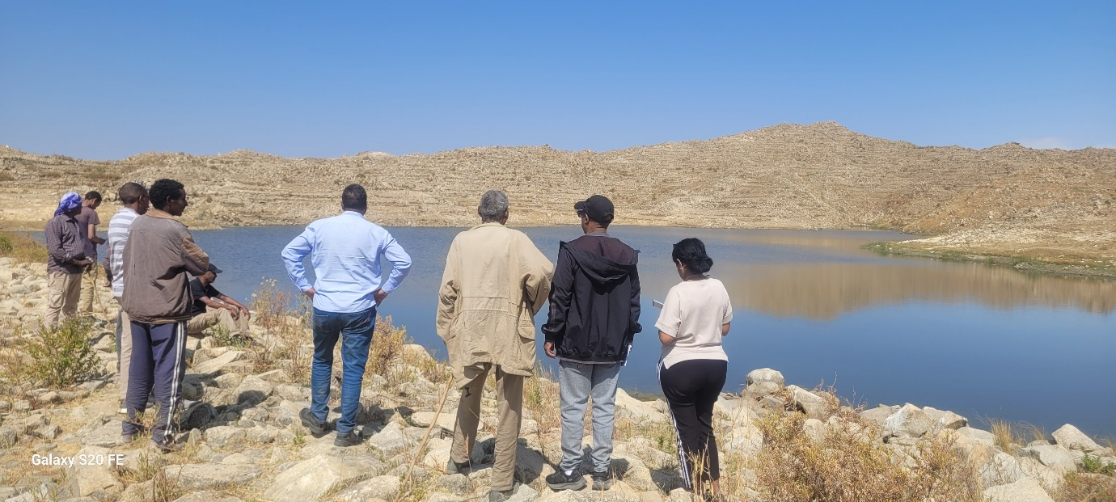
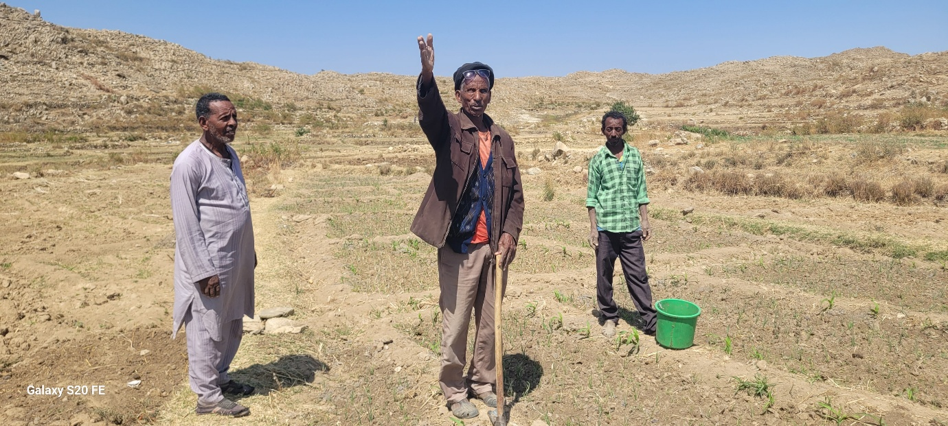
Site 3: Adi Tsenaf micro-dam, estimated storage capacity 600,000m³ Zoba, and ≈ 45ha command area, Maekel
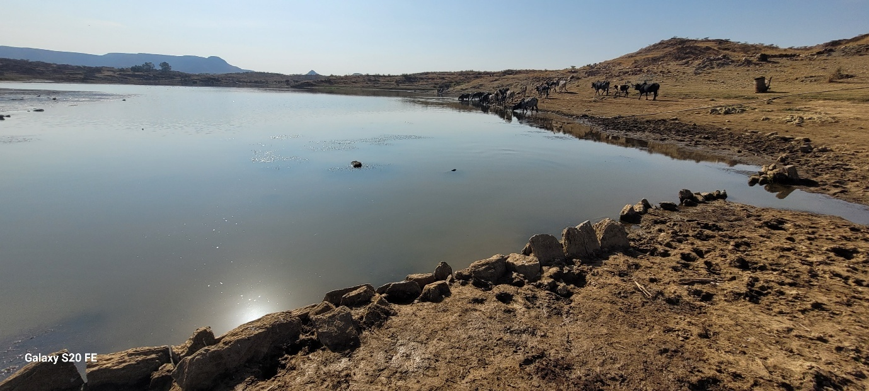
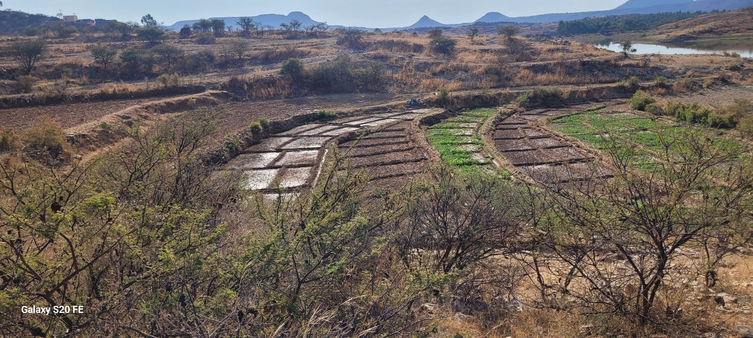
Site 4: Himbirti, Zoba Maekel
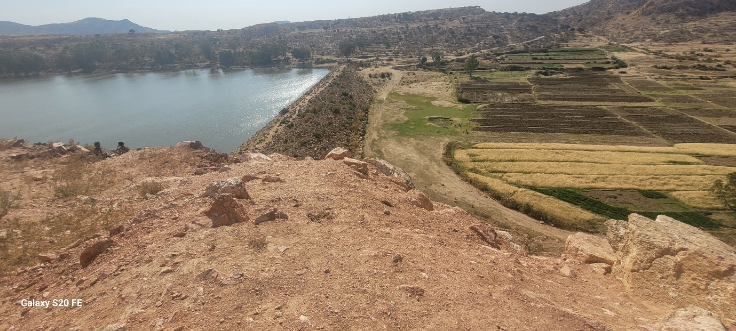
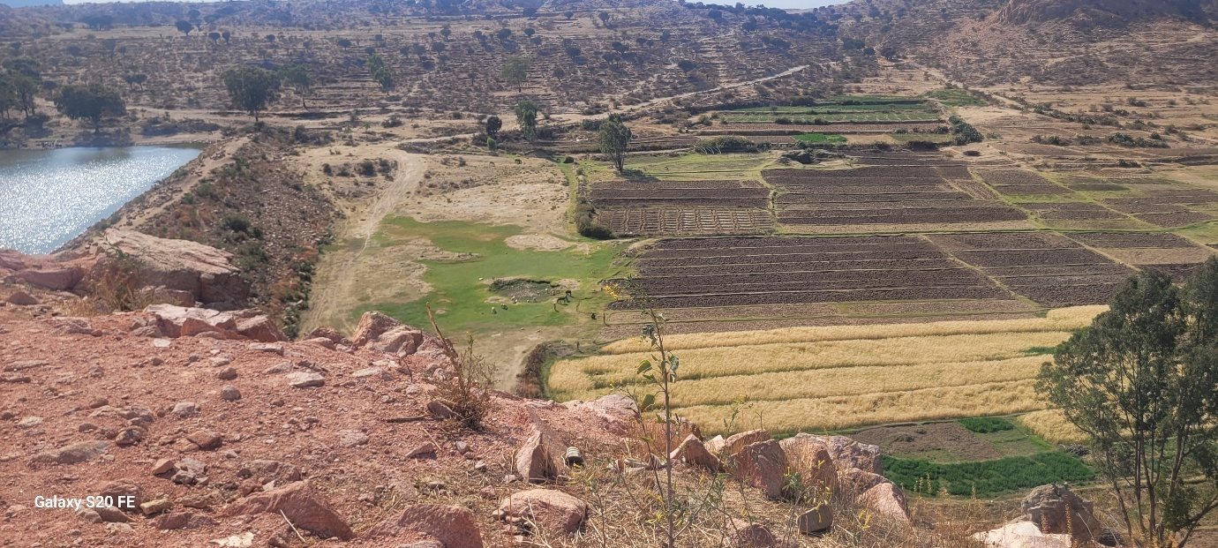
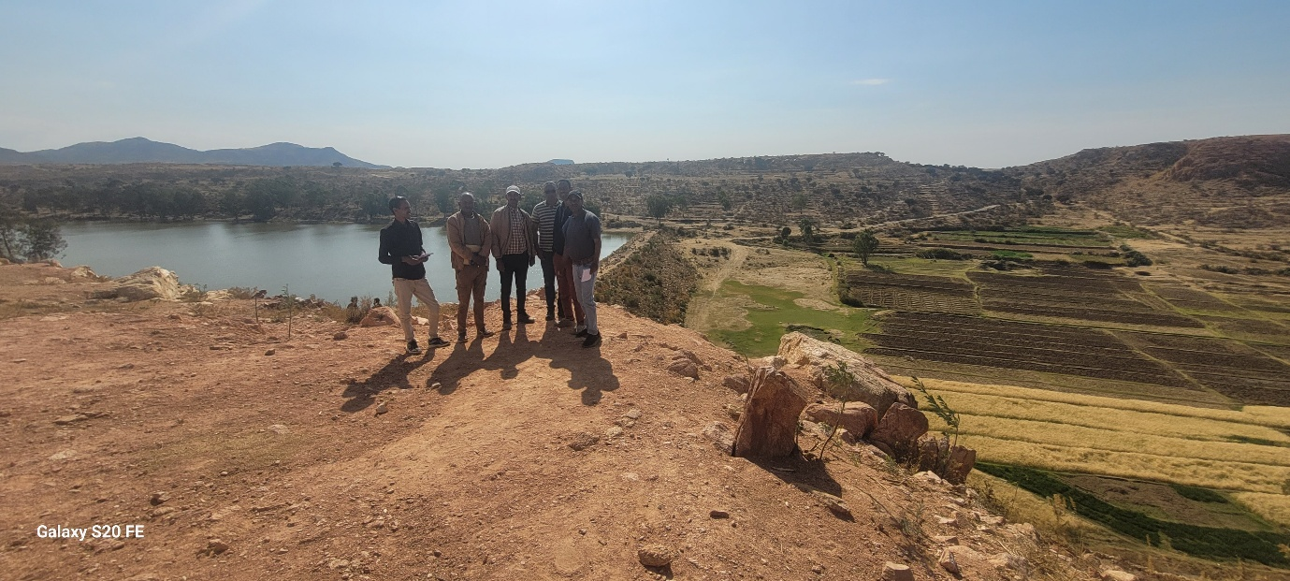
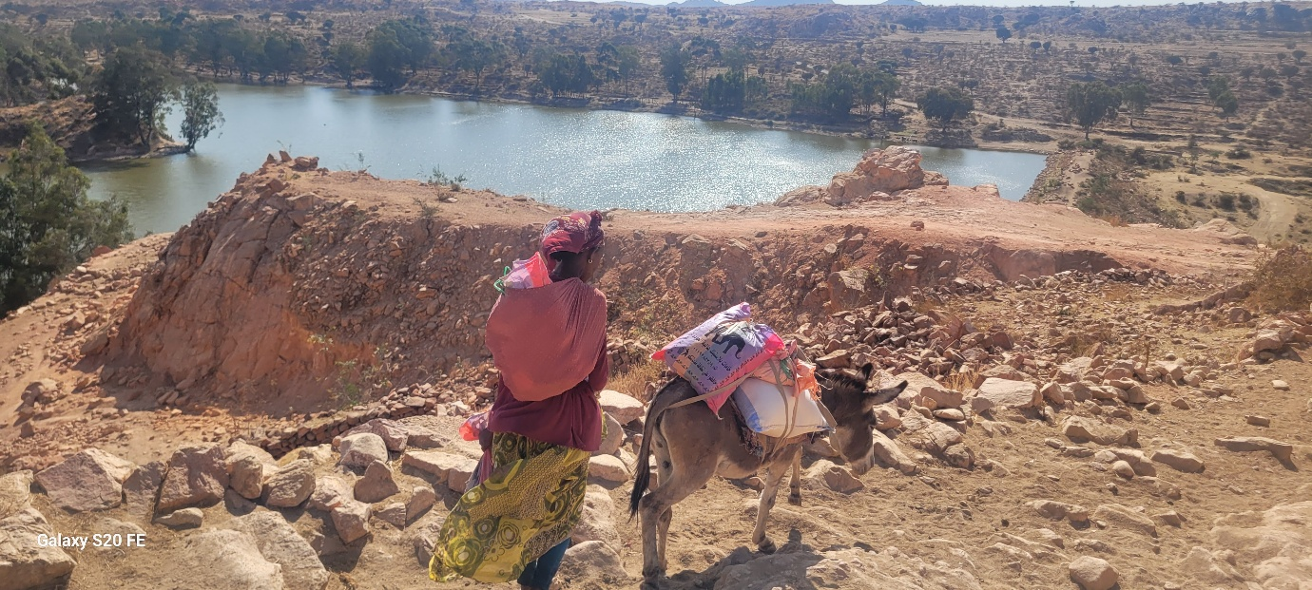
Site 5: Tseazega, Zoba Maekel
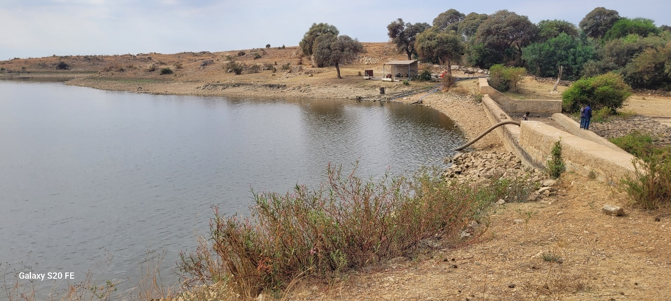
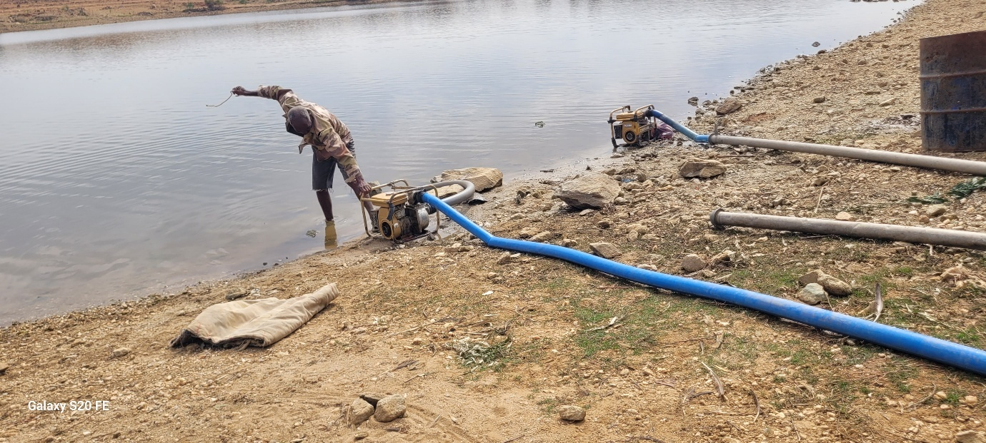
Site 6: Ametsi, estimated storage capacity 118,720m³ and ≈ 25ha command area, Zoba Maekel
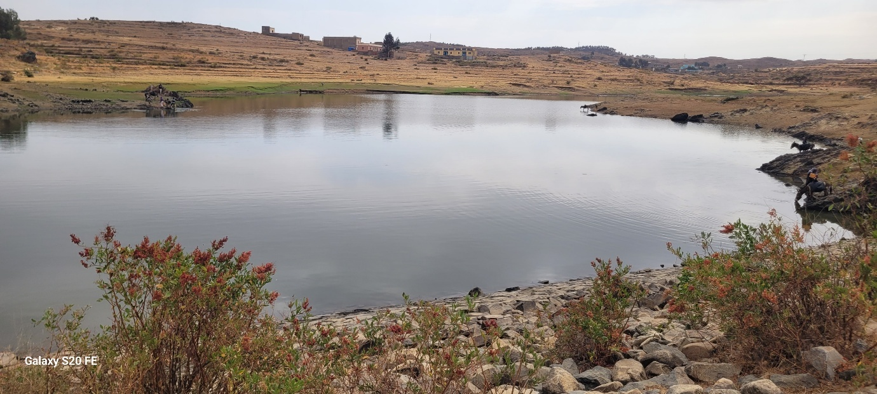
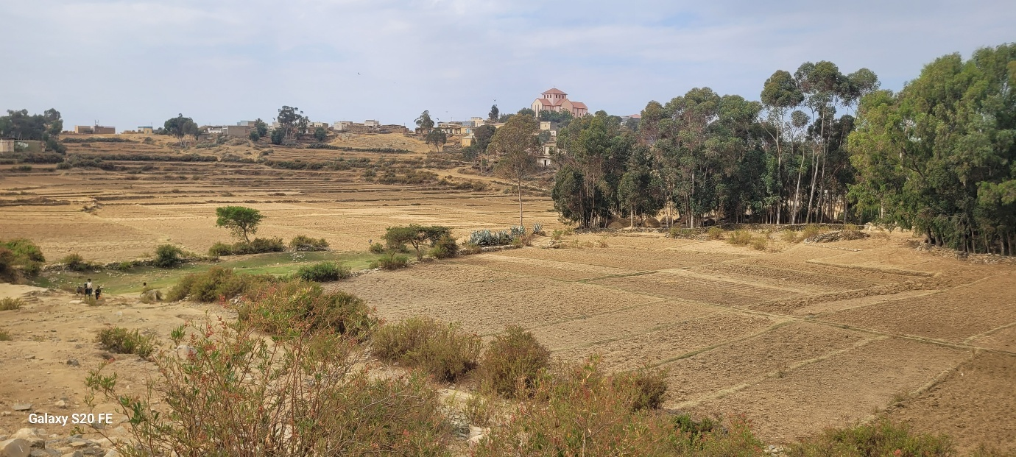
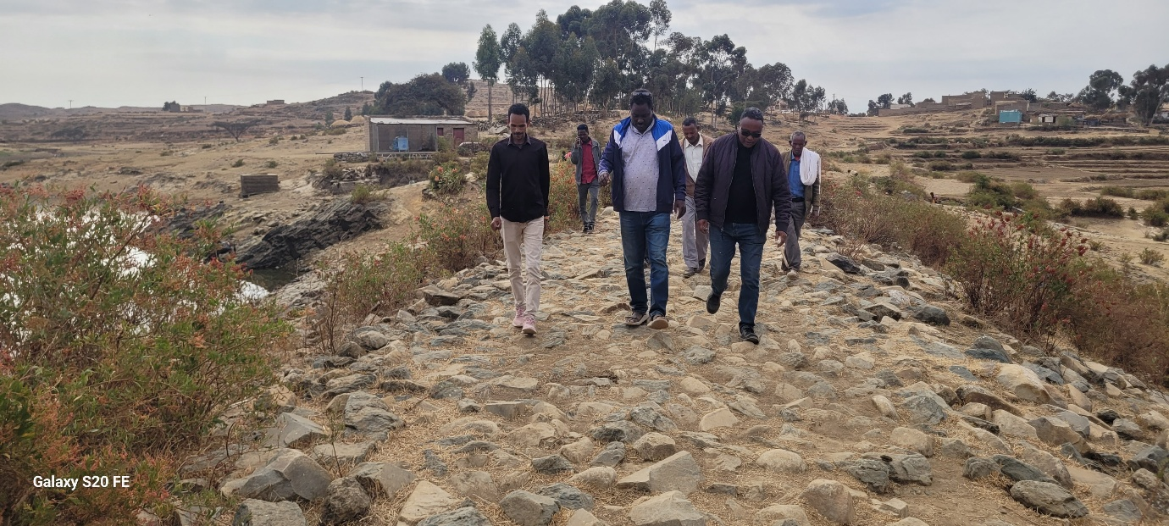
Site 7: Aibaba, estimated storage capacity 200,000m³ and, 25ha command area, Zoba Anseba
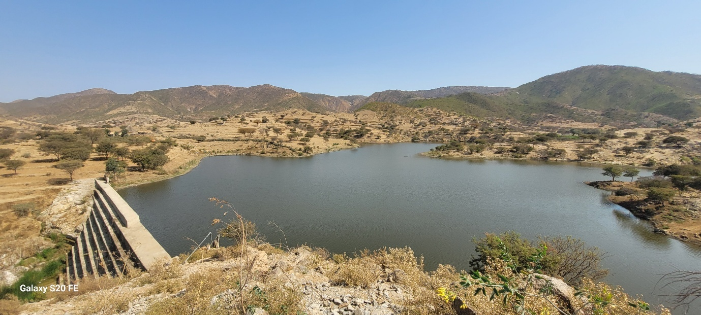
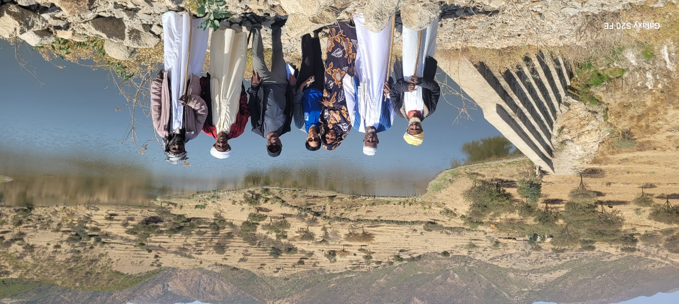
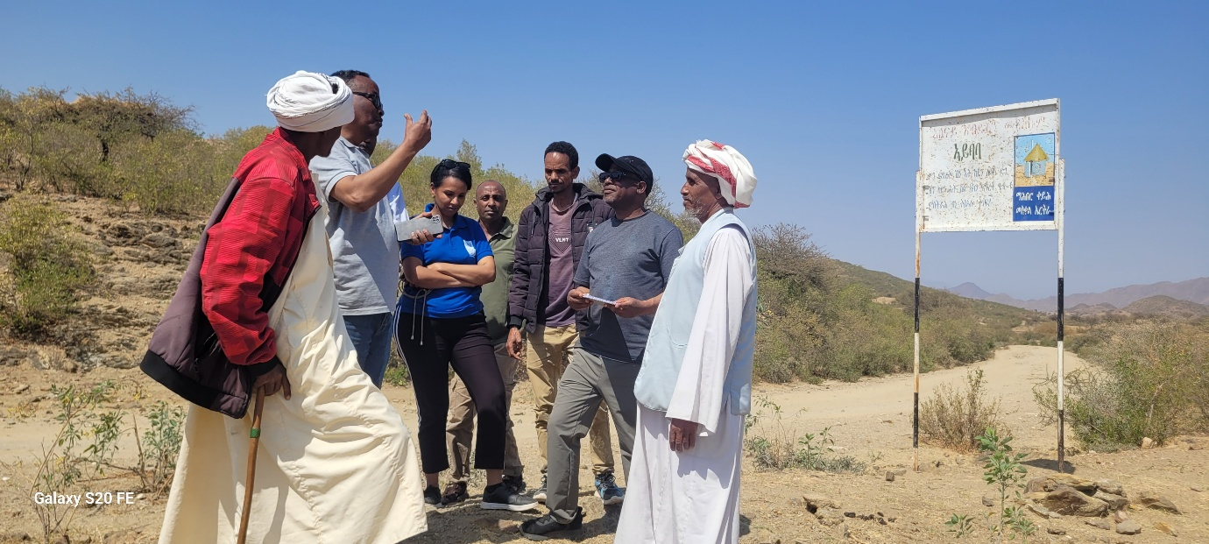
Site 8: Deki Zeru, estimated storage capacity 156,000m³, and 20ha, Zoba Anseba
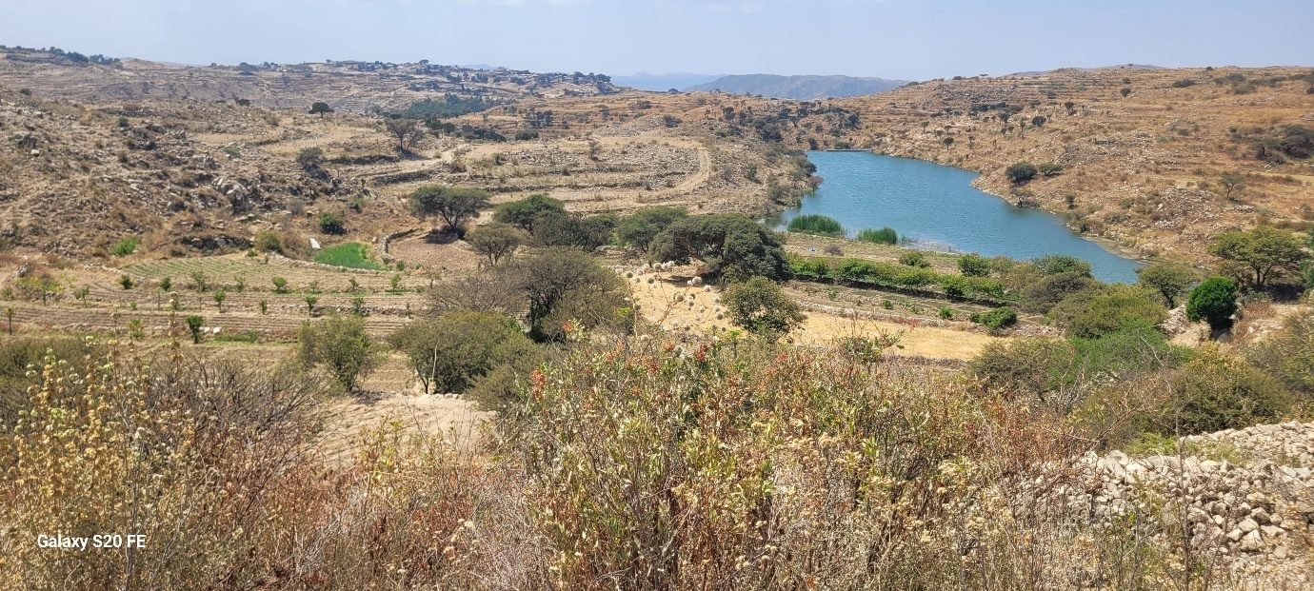
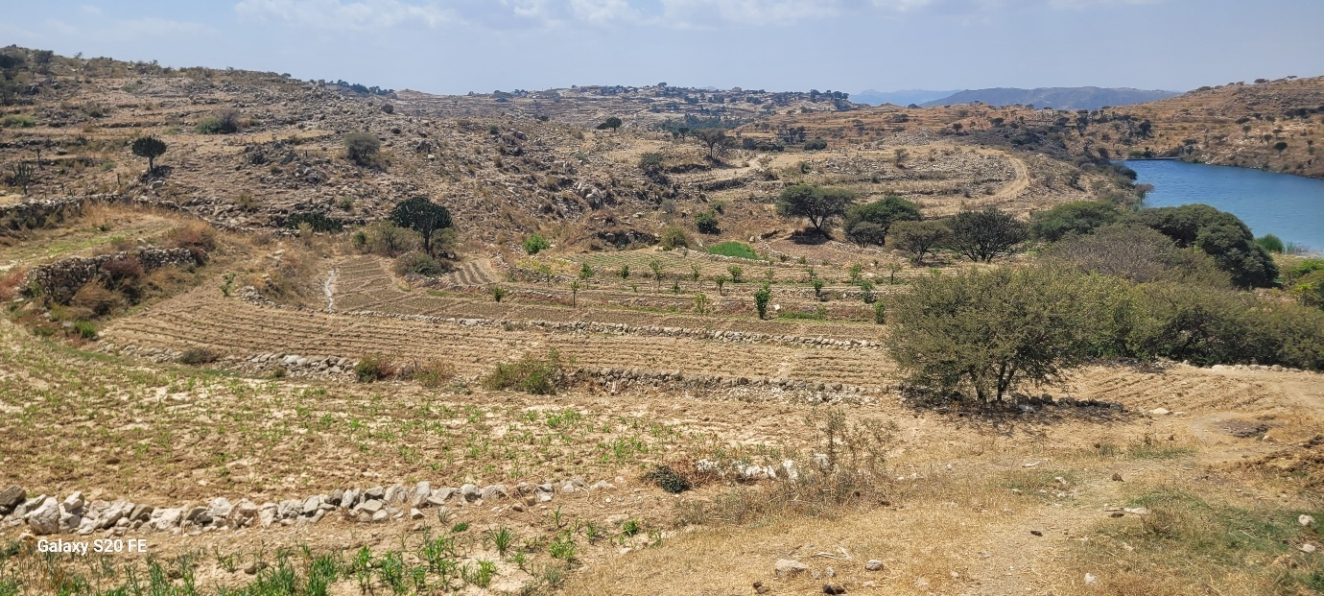
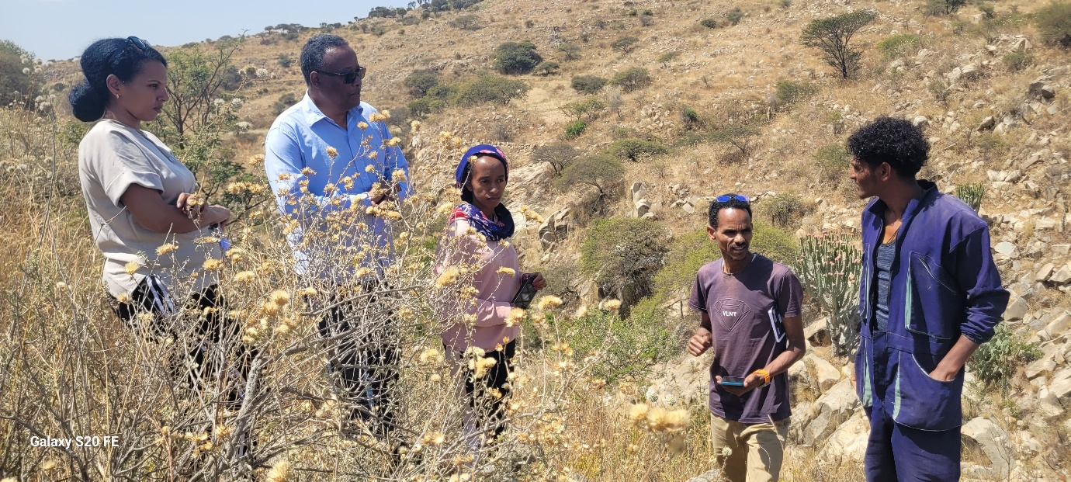
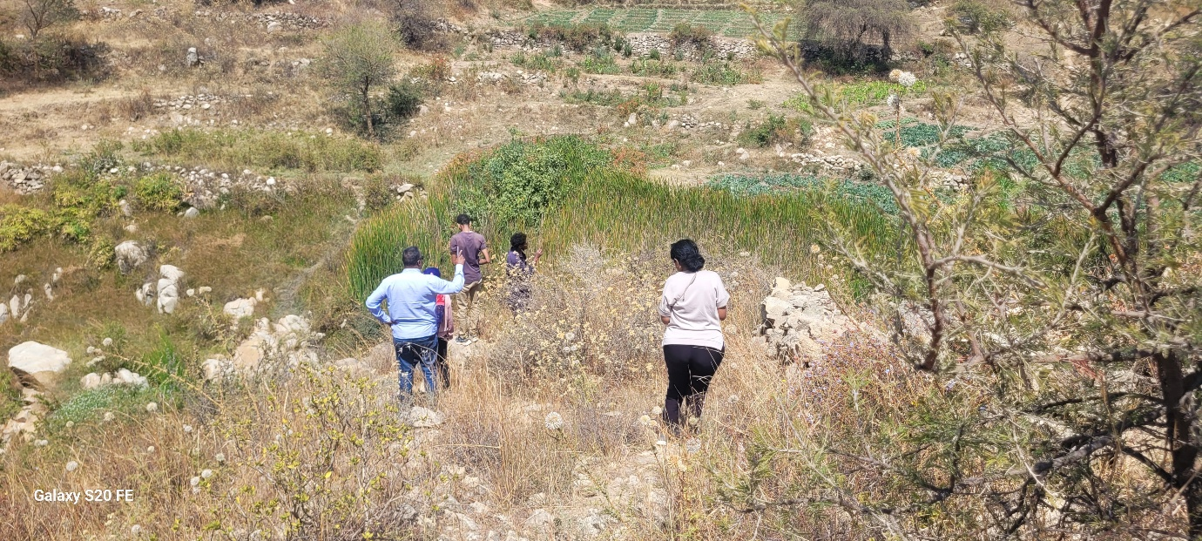
Site 9: Liban, estimated storage capacity 118,087m3 and ≈ 45ha command area, Zoba Gash Barka
